**What is Cloud Computing?**

• **It is the use of remote servers on the internet to store, manage and process data rather than a local server or personal computer.**

**There are basically 3 categories in cloud computing:**

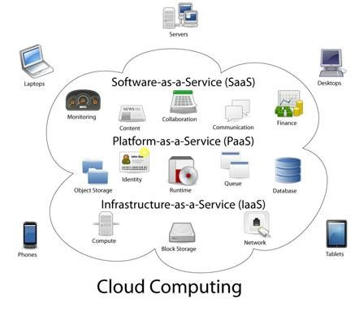

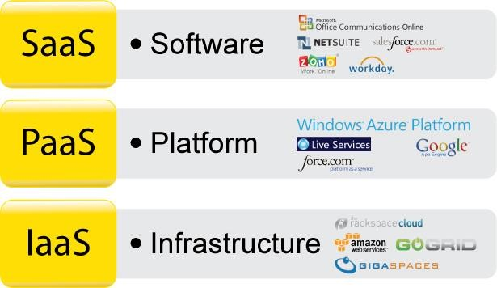

**What is AWS?**

* AWS stands for **Amazon Web Services**. o The AWS service is provided by the Amazon that uses distributed IT infrastructure to provide different IT resources available on demand. It provides different services such as infrastructure as a service (IaaS), platform as a service (PaaS) and packaged software as a service (SaaS).
* Amazon launched AWS, a cloud computing platform to allow the different organizations to take advantage of reliable IT infrastructure.

**Uses of AWS** o A small manufacturing organization uses their expertise to expand their business by leaving their IT management to the AWS.

* A large enterprise spread across the globe can utilize the AWS to deliver the training to the distributed workforce. o An architecture consulting company can use AWS to get the high-compute rendering of construction prototype.
* A media company can use the AWS to provide different types of content such as ebox or audio files to the worldwide files.

**AWS (Amazon Web Services)**

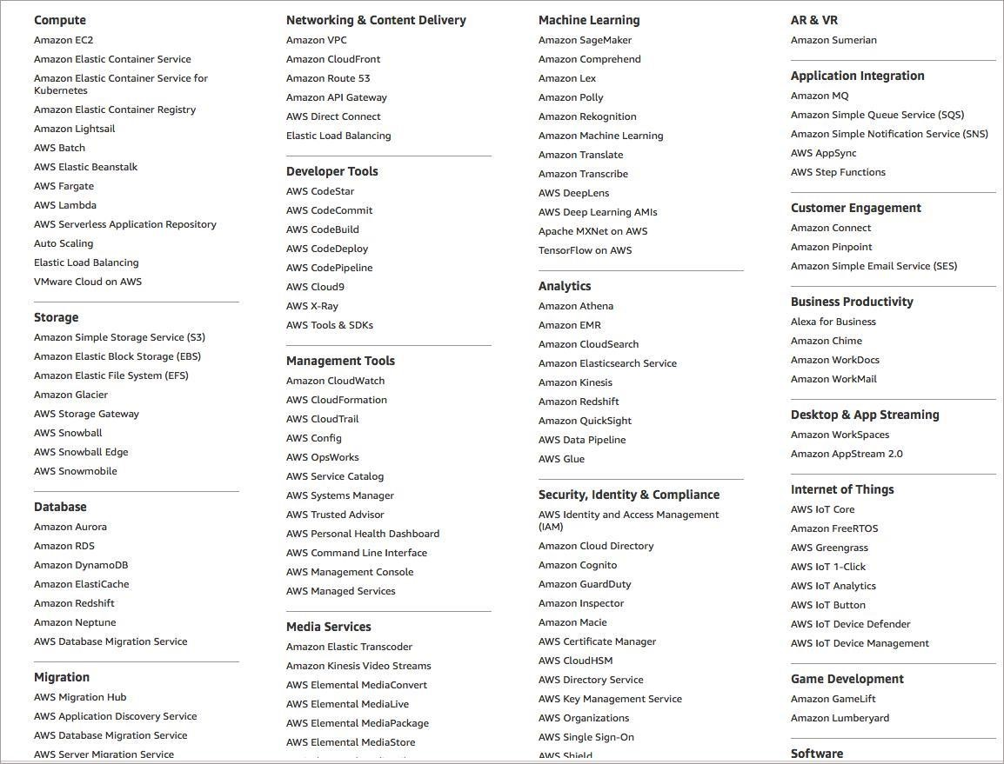 different domains in which AWS offer services:

* **Compute**

It is used to process data on the cloud by making use of powerful processors which serve multiple instances at a time.

* **Storage and Content Delivery**

The storage as the name suggests, is used to store data in the cloud, this data can be stored anywhere but content delivery on the other hand is used to cache data nearer to the user so as to provide low latency.

* **Database**

The database domain is used to provide reliable relational and non-relational database instances managed by AWS.

* **Networking**

It includes services which provide a variety of networking features such as security, faster access etc.

* **Management Tools**

It includes services which can be used to manage and monitor your AWS instances.

* **Security and Identity**

It includes services for user authentication or limiting access to a certain set of audience on your AWS resources.

* **Application Services**

It includes simple services like notifications, emailing and queuing.

To include every customer need under the sun, amazon has further categorized services under each domain. Let’s discuss each one of them.

**Compute Services**

* Amazon EC2
* Amazon EC2 Auto Scaling
* Amazon Elastic Container Registry
* Amazon Elastic Container Service
* Amazon Elastic Kubernetes Service
* Amazon Lightsail
* AWS Batch
* AWS Elastic Beanstalk
* AWS Fargate
* AWS Lambda
* AWS Serverless Application Repository
* AWS Outposts
* VMware Cloud on AWS

* **AWS EC2**



* EC2 stands for Amazon Elastic Compute Cloud. o It is a web service which provides re-sizable compute capacity in the cloud. o It is designed to make the web scale computing easier for developers

**Therefore, AWS EC2 offers 5 types of instances which are as follows:**

* **General Instances** o For applications that require a balance of performance and cost.

▪ E.g email responding systems, where you need a prompt response as well as the it should be cost effective, since it doesn’t require much processing.

* **Compute Instances** o For applications that require a lot of processing from the CPU.

▪ E.g analysis of data from a stream of data, like Twitter stream

* **Memory Instances** o For applications that are heavy in nature, therefore, require a lot of RAM.

▪ E.g when your system needs a lot of applications running in the background i.e multitasking.

* **Storage Instances** o For applications that are huge in size or have a data set that occupies a lot of space. ▪ E.g When your application is of huge size.
* **GPU Instances** o For applications that require some heavy graphics rendering. ▪ E.g 3D modelling etc.

**Now, every instance type has a set of instances which are optimized for different workloads:**

* General Instances o t2 o m4 o m3
* Compute Instances o c4 o c3
* Memory Instances o r3

o x1

* Storage Instances o i2 o d2
* GPU Instances o g2

**AWS Elastic Beanstalk**



Elastic Beanstalk quickly deploy and manage applications in AWS without worrying about the underlying infrastructure.

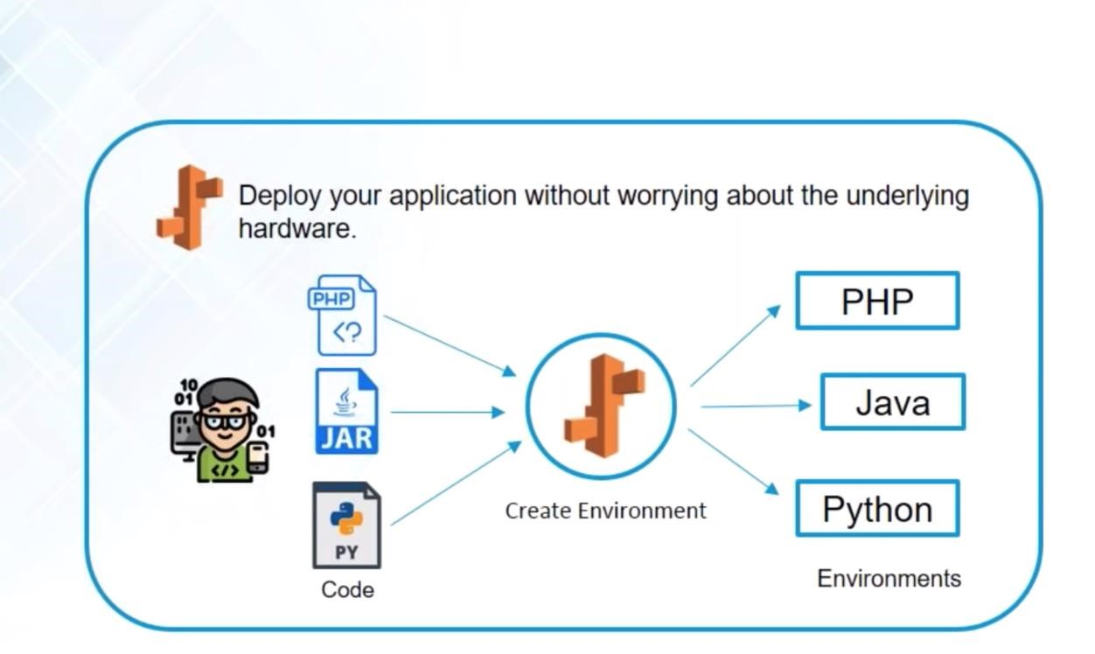

* Elastic Beanstalk is a service provided by AWS which is used for deploying infrastructure which consists of many AWS services.
* These services include **AWS S3**, EC2, **auto-scaling**, cloud watch, Elastic load balancer, and simple notification service.
* It is easy to start with Elastic Bean Stalk as you can see **AWS Management Console**, the command line interface or the API.
* All you have to do is choose your platforms such as Node.js or Ruby and Amazon EC2 instance type.
* After the code is uploaded the AWS Elastic Beanstalk will handle the rest of the activities such as provisioning, load balancing, auto-scaling, and other activities.
* AWS does not implement any extra charges for Elastic Beanstalk as you have pay only for the AWS resources needed to run your applications without any hidden or upfront cost.

|  |  |
| --- | --- |
| EC2 | Beanstalk |
| EC2 is Amazon's service that allows you to create a server (AWS calls these instances) | Elastic Beanstalk is one layer of abstraction away from the EC2 layer. Elastic Beanstalk |
| in the AWS cloud. You pay by the hour and only what you use. You can do whatever you want with this instance as well as launch n number of instances. | will setup an "environment" for you that can contain a number of EC2 instances, an optional database, as well as a few other AWS components such as a Elastic Load  Balancer, Auto-Scaling Group, Security Group. Then Elastic Beanstalk will manage these items for you whenever you want to update your software running in AWS. Elastic Beanstalk doesn't add any cost on top of these resources that it creates for you. If you have 10 hours of EC2 usage, then all you pay is 10 compute hours. |
| We can’t run our apps on plain EC2 | We can run our apps on EB |
| with an EC2 instance, you can turn it off and on at any time and save money. You can have everything on one and save money too. For large operations, this won’t matter, but for a bootstrapped start-up, this makes a difference. | Beanstalk is a good product and really a good fit if you know your service is going to grow. You get load balancers and auto scaling configured automatically, which is  way out of my domain |

**AWS Elastic Load Balancing**



ELB automatically manages the workload on your instances and distributes them to other instances in case of an instance failure.

**What is Load Balancer?**

Load Balancer is a virtual machine or appliance that balances your web application load that could be Http or Https traffic that you are getting in. It balances a load of multiple web servers so that no web server gets overwhelmed.

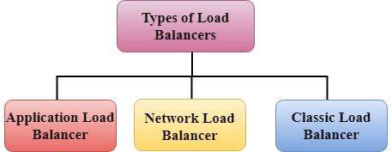

**Application Load Balancer**

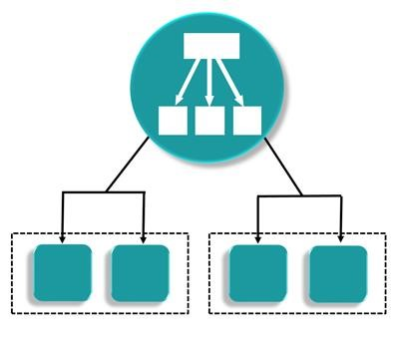 o An Amazon Web Services (AWS) launched a new load balancer known as an Application load balancer (ALB) on August 11, 2016.

* It is used to direct user traffic to the public AWS cloud. o It identifies the incoming traffic and forwards it to the right resources. For example, if a URL has /**API** extensions, then it is routed to the appropriate application resources.
* It is operated at Layer 7 of the OSI Model. o It is best suited for load balancing of HTTP and HTTPs traffic. o Application load balancers are intelligent, sending specific requests to specific web servers. o If we take an example of TESLA. We have three models of TESLA, i.e., TESLA Model X, TESLA Model S, and TESLA Model 3 and TESLAs have onboard computing facility. You will have a group of web servers that serve the Model X, a group of web servers that serve the Model S, and similarly for Model 3. We have one Load balance that checks whether the incoming traffic comes from either Model X, Model S or Model 3, and then sends it to the intended froup of servers. **Network Load Balancer**

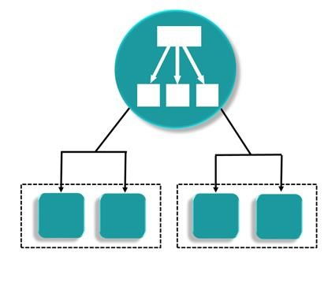 o It is operated at the Layer 4 of the OSI model. o It makes routing decisions at the transport layer (TCP/SSL), and it can handle millions of requests per second.

* When a load balancer receives a connection, it then selects a target from the target group by using a flow hash routing algorithm. It opens the TCP connection to the selected target of the port and forwards the request without modifying the headers.
* It is best suited for load balancing the TCP traffic when high performance is required.

**Classic Load Balancer**

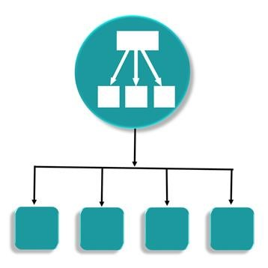 o It is operated at Layer 4 of the OSI model.

* It routes the traffic between clients and backend servers based on IP address. o For example, an Elastic Load balancer receives a request from a client on TCP port 80, it will then routes the request to a specified port of backend servers. The port on which the Load Balancer routes to the target server will be having port number 80. The backend server will then send the requested data back to the ELB, which will then forward the Backend server reply to the client. According to the client's perspective, the request has been fulfilled by the ELB, not by the backend server.
* Classic Load balancers are legacy Elastic load balancers.
* It can also be used for load balancing the HTTP or HTTPs traffic and use layer 7-specific features, such as X-forwarded and sticky sessions.
* You can also use the Layer 4 load balancing for applications that rely purely on the TCP protocol.

**AWS Lambda**



AWS Lambda is used to execute backend code without worrying about the underlying architecture, you just upload the code and it runs, it’s that simple!

AWS Lambda is a compute service offered by Amazon.

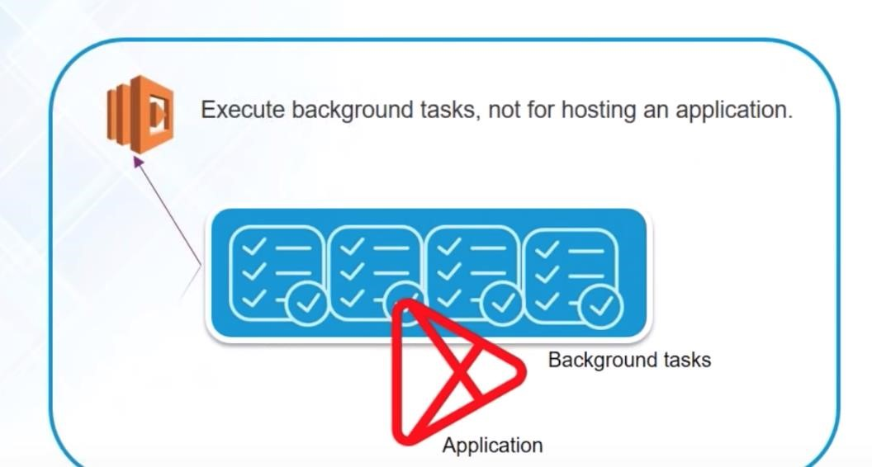

What is AWS Lambda?

* Amazon explains, AWS Lambda (λ) as a ‘serverless’ compute service, meaning the developers, don’t have to worry about which AWS resources to launch, or how will they manage them, they just put the code on lambda and it runs, it’s that simple! It helps you to focus on core-competency i.e. App Building or the code.
* Lambda is used to encapsulate Data centres, Hardware, Assembly code/Protocols, high-level languages, operating systems, AWS APIs.
* Lambda is a compute service where you can upload your code and create the Lambda function.
* Lambda takes care of provisioning and managing the servers used to run the code.
* While using Lambda, you don't have to worry about scaling, patching, operating systems, etc.
* **Then why not EC2?**

|  |  |
| --- | --- |
| EC2 | Lambda |
| If you were to use EC2, you would have to architect everything i.e. load balancer, EBS volumes, software stacks etc  For example, in EC2 you would be installing the software packages on your virtual machine which would support your code | In lambda you don’t have to worry about anything, just insert your code, and AWS will manage the rest! in Lambda you don’t have to worry about any VM, just insert plain code and Lambda will execute it for you. |

* But, if your code will be running for hours, and you expect a continuous stream of requests, you should probably go with EC2, because the architecture of Lambda is for a sporadic kind of workload, wherein there will be some quiet hours and some spikes in the no. of requests as well.
* For example, logging the email activity for say a small company, would see more activity during the day than in the night, also there could be days when there are less emails to be processed, and sometimes the whole world could start emailing you! In both the cases, Lambda is at your service.
* Considering this use case for a big social networking company, where the emails are never ending because it has a huge user base, Lambda may not be the apt choice.

**AWS Autoscaling**



* The Autoscaling feature is used to scale up and down automatically as and when required.
* The application available at AWS requires space and load and the Auto Scaling helps us by providing surety that there is a sufficient number of Amazon EC2 instances available to handle that load.
* **You can set a limit on EC2 instances such that the number doesn’t go below this**.
* **The maximum numbers of EC2 instances can be set to be on a safer side.**
* **AWS Autoscaling ensures that your group has a sufficient amount of servers.**
* Auto-scaling automatically modifies the EC2 instance as per your demand changes.
* One can access Auto Scaling by signing into the **AWS Management Console**.
* AWS Auto-scaling helps you if you are using language-specific APIs rather than submitting requests over HTTP or HTTPS Auto Scaling provides a benefit of libraries, Sample code, tutorial, and other resources for the development of the software.
* It also helps us with some functions such as retrying requests, and handling error responses, making it is easier for the applicant to get started.

Amazon Elastic Container Service

AMAZON EC2 CONTAINER SERVICE (ECS)

* Amazon EC2 Container Service (Amazon ECS) is a highly scalable, fast, container management service that makes it easy to run, stop, and manage Docker containers on a cluster of Amazon EC2 instances.
* Amazon ECS uses **Docker images** in task definitions to launch containers on EC2 instances in our clusters.
* Docker is a technology that allows us to build, run, test, and deploy distributed applications that are based on Linux containers.

ECS is basically a set of APIs that turn EC2 instances into compute cluster for container management:

1. EC2 instances must call RegisterContainerInstance API to signal that they are ready to run containers.
2. Need to call RegisterTaskDefinition API to define the tasks (setting an image, command and memory for docker run etc.)
3. We use RunTask API to start a new task.
4. Lastly, we make a CreateService API call to run a long-running container.

* + We can start using Amazon EC2 Container Service (Amazon ECS) by creating a task definition, scheduling tasks, and configuring a cluster in the Amazon ECS console. **Note that we do not need any orchestration tools such as Mesos, Kubernetes or Docker Swarm.**

Amazon Elastic Kubernetes Service

AWS : EKS (ELASTIC CONTAINER SERVICE FOR KUBERNETES)

* + Amazon Elastic Container Service for Kubernetes (Amazon EKS) is a fully managed service that makes it easy for you to use Kubernetes on AWS without having to be an expert in managing Kubernetes clusters.
  + There are few things that we think developers will really like about this service.
  + First, Amazon EKS runs the upstream version of the open-source Kubernetes software, so you can use all the existing plugins and tooling from the Kubernetes community.
  + Applications running on Amazon EKS are fully compatible with applications running on any standard Kubernetes environment, whether running in on-premises datacentre’s or public clouds. This means that you can easily migrate your Kubernetes application to Amazon EKS with zero code changes. Second, Amazon EKS automatically runs K8s with three masters across three AZs to protect against a single point of failure.
  + This multi-AZ architecture delivers resiliency against the loss of an AWS Availability Zone.

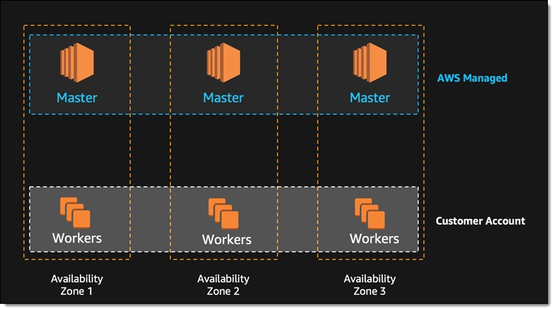

* + Third, Amazon EKS also automatically detects and replaces unhealthy masters, and it provides automated version upgrades and patching for the masters.
  + Last, Amazon EKS is integrated with a number of key AWS features such as Elastic Load Balancing for load distribution, IAM for authentication, Amazon VPC for isolation, AWS Private Link for private network access, and AWS CloudTrail for logging.

# AWS Fargate – A Compute Engine For ECS

* AWS Fargate is a compute engine for Amazon Elastic Container Service(ECS) that allows you to run containers without having to provision, configure & scale clusters of VMs that host container applications.
* AWS Fargate eliminates the need for users to manage the EC2 instances on their own.
* In fact, users don’t need to use EC2 instances at all.
* Fargate itself will act as compute engine.
* It lets you focus on elements like designing and constructing your application instead of managing the infrastructure that runs them.
* With **Fargate launch type**, all you need to do is package your application in containers, specify the memory and CPU requirements, define IAM policies & launch your application.
* AWS Fargate also makes it easy to scale your applications.
* Once you define all your application requirements, AWS Fargate manages all the scaling and infrastructure needed to run your containers in a highly-available manner.
* It seamlessly integrates with Amazon ECS & EKS, launches and manages your containers for you.

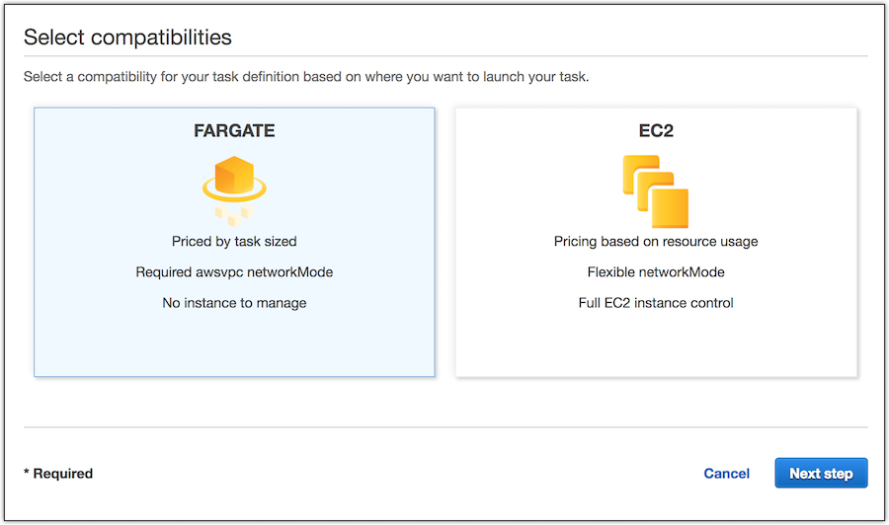

**Storage and Content Delivery**

Storage

* Amazon S3
* Amazon Elastic Block Store
* Amazon Elastic File System
* Amazon FSx for Lustre
* Amazon FSx for Windows File Server
* Amazon S3 Glacier
* AWS Storage Gateway

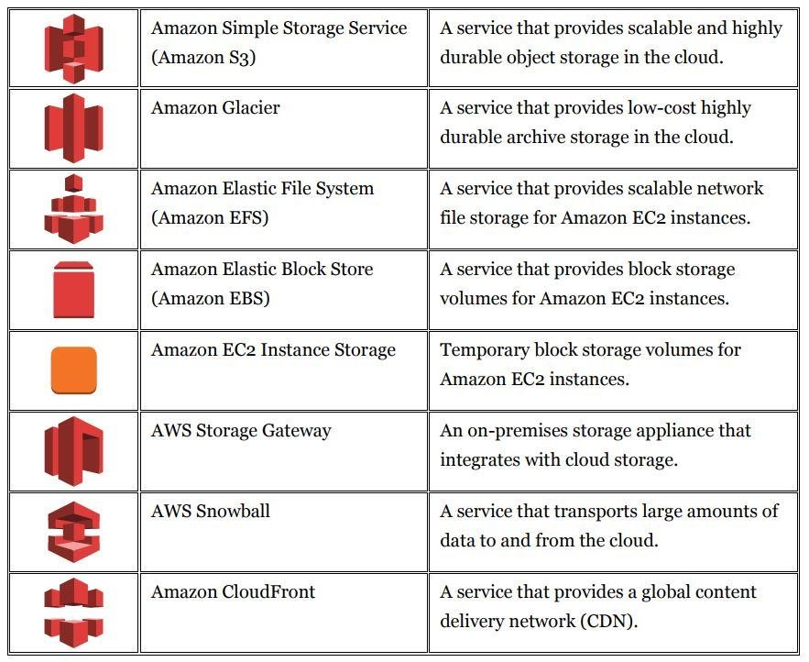

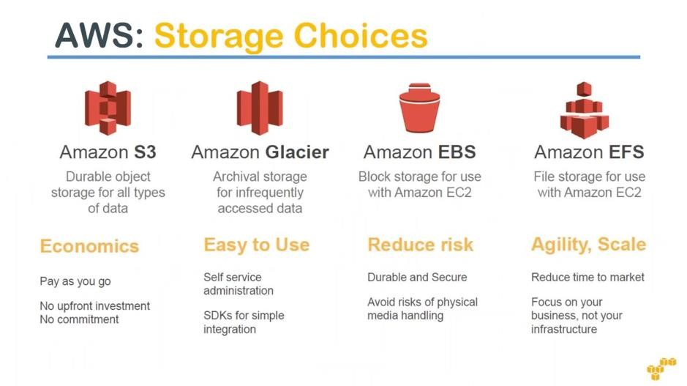

* **S3 AWS**



S3 stands for simple storage service, it is used for storing data in the form of objects in the AWS Cloud.

* Amazon Simple Storage Service (S3) is a storage for the internet. o It is designed for large-capacity, low-cost storage provision across multiple geographical regions. o Amazon S3 provides developers and IT teams with **Secure**, **Durable** and **Highly Scalable** object storage. o S3 is a safe place to store the files. o It is Object-based storage, i.e., you can store the images, word files, pdf files, etc. o The files which are stored in S3 can be from 0 Bytes to 5 TB. o It has unlimited storage means that you can store the data as much you want.
* Files are stored in Bucket. A bucket is like a folder available in S3 that stores the files.
* S3 is a universal namespace, i.e., the names must be unique globally. Bucket contains a DNS address. Therefore, the bucket must contain a unique name to generate a unique DNS address.

**Amazon Glacier**

*  o Glacier is an archiving service offered by Amazon, which offers low cost data archiving.
* **Amazon Glacier is extremely low cost, secure, and durable storage service for data archiving and backup**.
* It is designed to keep the cost low and optimized for the cold data where the retrieval time is 3 to 4 hours. Within Glacier, the user can reliably store the small and large amount of data.
* In AWS Glacier, there is no limit for the data user stores. Moreover, the data is secure and can access easily. o Amazon Glacier helps to protect the data by redundantly storing it on multiple devices using multiple facilities.
* AWS Glacier has a Data Integrity Check which regularly monitors the data in the Glacier.
* It also provides security and fine-grained access to the data of the user with AWS Access Management policies.

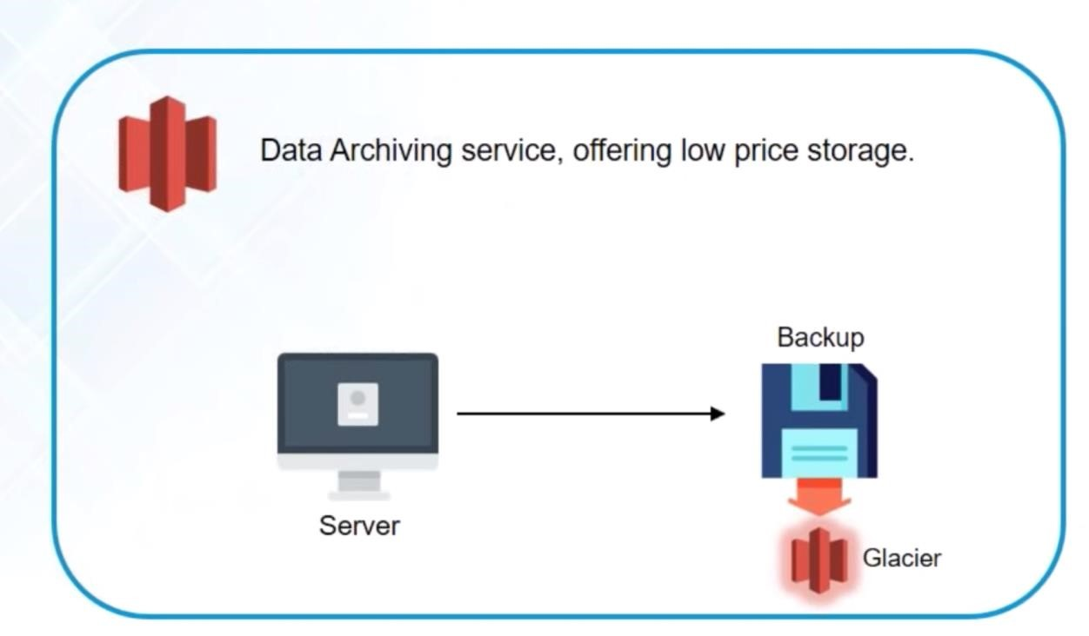

**Amazon EBS**



Amazon Elastic Block Storage is a storage service wherein each block of storage acts like a separate hard drive.

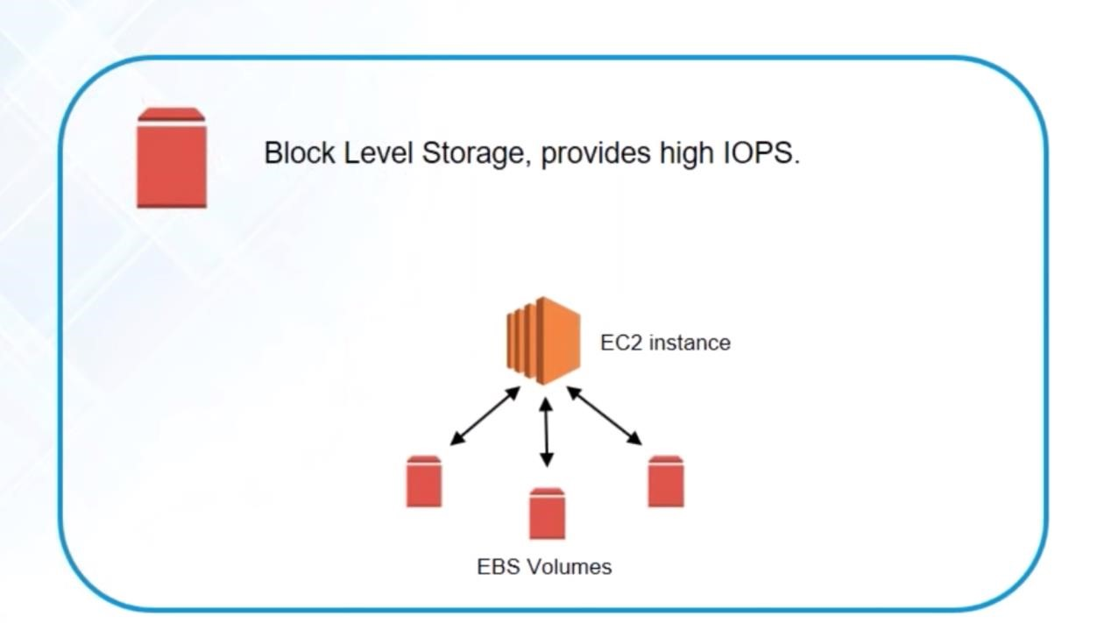

* **Amazon Elastic Block Store** (EBS) is a block storage system used to store persistent data.
* Amazon EBS is suitable for EC2 instances by providing highly available block level storage volumes.
* It has three types of volume

1. General Purpose (SSD) 2. Provisioned IOPS (SSD)

3. Magnetic.

**Amazon EBS Benefits**

* **Reliable and secure storage** − Each of the EBS volume will automatically respond to its Availability Zone to protect from component failure.
* **Secure** − Amazon’s flexible access control policies allows to specify who can access which EBS volumes.

Access control plus encryption offers a strong defense-in-depth security strategy for data.

* **Higher performance** − Amazon EBS uses SSD technology to deliver data results with consistent I/O performance of application.
* **Easy data backup** − Data backup can be saved by taking point-in-time snapshots of Amazon EBS volumes.

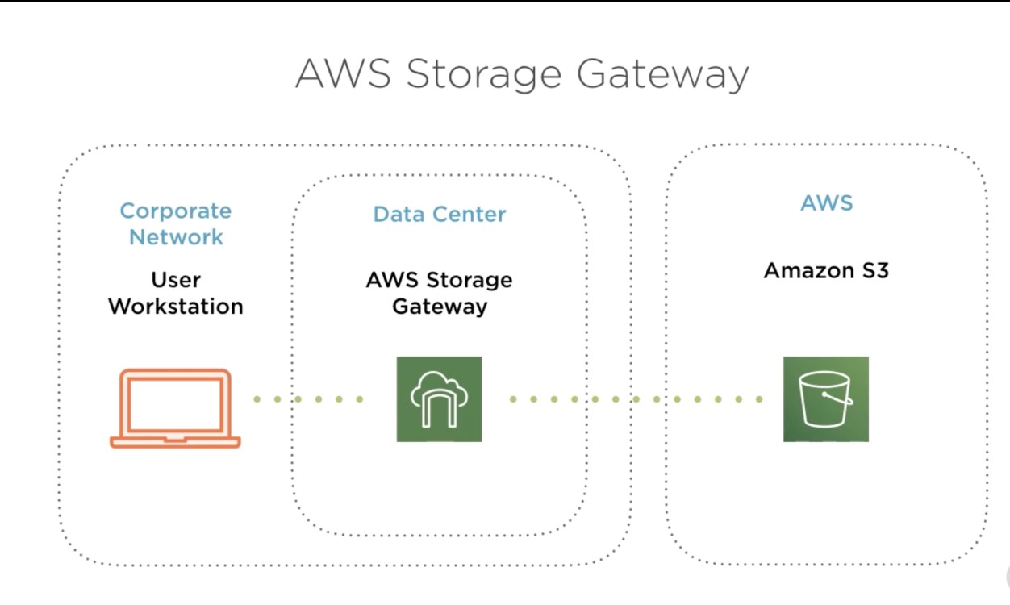

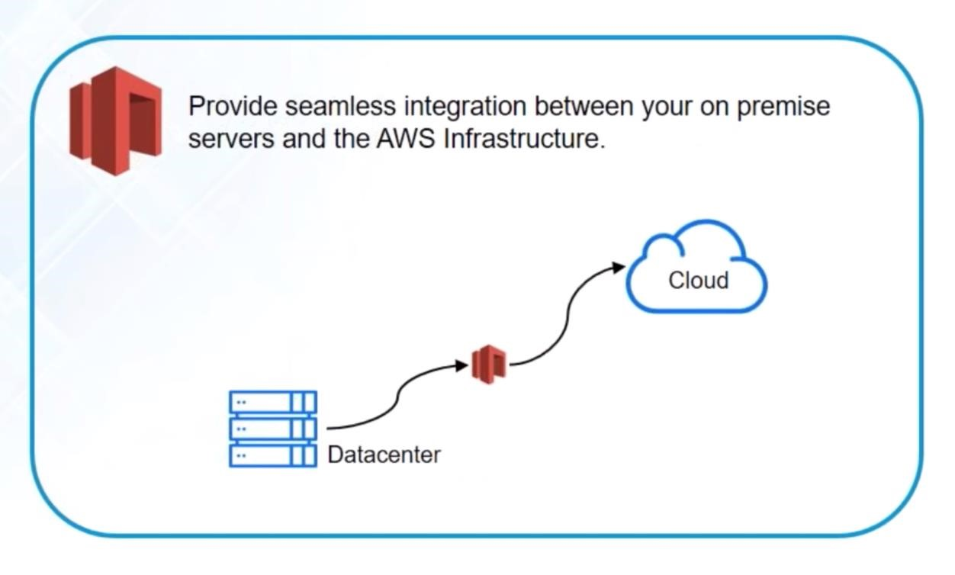

**What is AWS Storage Gateway?**

* **Amazon Storage Gateway is a modified storage service which enables the applications to use the AWS Cloud for storage purpose**.
* **Amazon SG can help for backup and archiving, cloud processing, disaster recovery, and migration**.
* Standard storage protocol such as NFS, SMB, and Amazon EBS connects the applications to a gateway appliance using **standard storage protocol**.
* The gateways get connected to the storage services such as **Amazon S3**, Amazon Glacier, and **Amazon EBS**.
* This service benefits the user in many ways such as It includes highly-optimized data transfer mechanism.
* Low-latency data along with the on-premise local cache provides access to the data.

**CloudFront CDN**

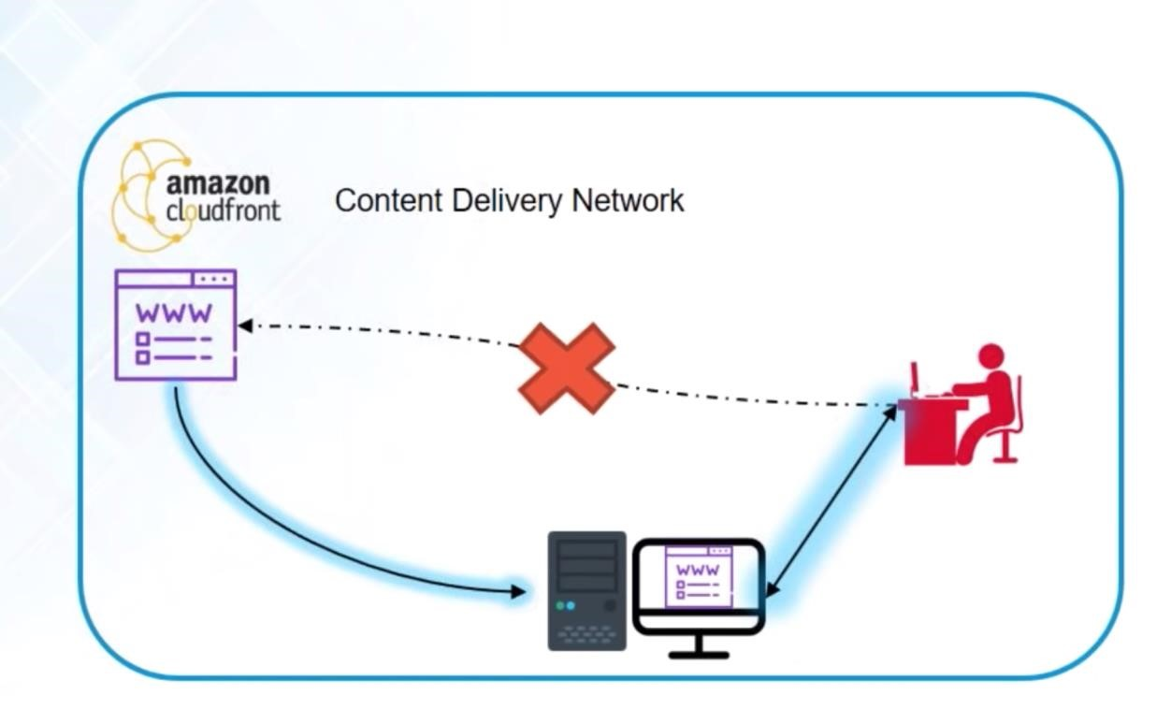

* CloudFront CDN (Computer Delivery Network) is a system of distributed servers that deliver web pages and other web content to a user based on the geographic locations of the user, the origin of the webpage and a content delivery server.
* Suppose I am running the website outside the UK and I am serving the website all around the world.
* When the user wants to access my website, then they request to the web server, and users from different countries will have different latency.
* For example, People who live in Australia will have more latency than those who stay in India.
* South Africa has a terrible latency, but they would run internet backbone that makes quicker to connect to the UK.
* This is how it works with CloudFront CDN in which people spread all around the world, and they can turn on access to the web page, audio files, etc. in the UK. **Snowball**
* The **Snowball** is a way of transferring your data physically. In this Amazon sends an equipment to your premises, on which you can load the data. It has a kindle attached to it which has your shipping address when it is shipped from Amazon. When data transfer is complete on the Snowball,
* 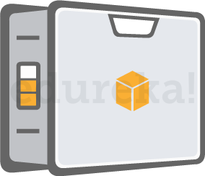
* kindle changes the shipping address back to the AWS headquarters where the Snowball has to be sent.
* The Snowball is ideal for customers who have large batches of data move. The average turnaround time for Snowball is 5-7 days, in the same time Transfer Acceleration can transfer up to 75 TB of data on a dedicated 1Gbps line. So depending on the use case, a customer can decide.

**Database**

**AWS database service includes the following services:**

* **Amazon Relational Database Service:** It supports six (Amazon aurora ,MySQL ,PostgreSQL’s Server ,Oracle, MariaDB)commonly used database engines.
* **Amazon Aurora:** It is a MySQL-Compatible relational database with five times performance. o **Amazon DynamoDB:** It is a fast and flexible NoSQL database service. o **Amazon Redshift:** It is a petabyte-scale data warehouse service. o **Amazon Elasticache:** It is an in-memory cache service with support for Memcached and Redis.
* **AWS Database Migration Service:** It is a service that provides easy and inexpensive to migrate your databases to AWS cloud.

**The Amazon Relational Database Service (RDS AWS)** is a web service that makes it easier to set up, operate, and scale a relational database in the cloud. It provides cost-efficient, re-sizable capacity in an industry-standard relational database and manages common database administration tasks.

So people often develop a misconception, when they confuse **RDS with a database.**

**RDS is** not **a database, it’s a service that manages databases**, having said that, let’s discuss the databases that RDS can manage as of now:

* Amazon aurora o Mysql o PostgreSQL o SQL Server o Oracle o MariaDB

* **Amazon Aurora**

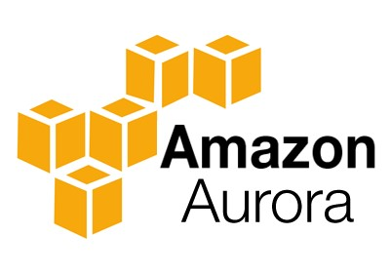

It is a relational database engine that combines the speed and reliability of high-end commercial databases and the cost effectiveness and simplicity of open-source databases.

* It is a relational database, and closed source database engine. o It is compatible with MySQL and delivers five times throughput of MySQL on the same hardware.
* It is also compatible with PostgreSQL and delivers three times throughput of PostgreSQL on the same hardware.
* Amazon RDS with Aurora manages the time-consuming administrative tasks such as software installation, patching, and backups.
* The main features of Aurora are fault-tolerant, distributed, a self-healing storage system that auto-scales upto 64 TB per database instance.
* It provides high-performance, availability, point-in-time recovery, continuous backed up to S3, and replication across three availability zones.

* **Amazon RDS**



Amazon RDS is a managed relational database service which does routine database tasks in 6 familiar databases like Amazon Aurora, MySQL, MariaDB, Oracle, Microsoft SQL Server, and PostgreSQL.

* **Amazon DynamoDB**



It is a fully managed No-SQL database service. It is known for extremely low latencies and scalability.

# Amazon DynamoDB

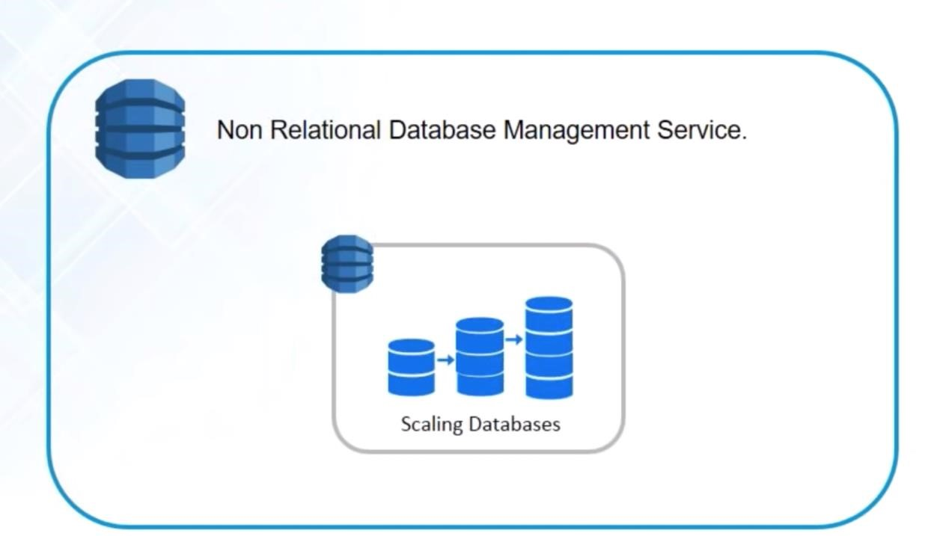

DynamoDB is a fully managed NoSQL database service provided by Amazon. These days, databases have become the backbone for any company irrespective of how big they are. Traditional database systems which were initially used, are not the go-to solution today because of the dynamic change in requirements and type of data procured. In this Amazon DynamoDB tutorial, I will be discussing the new and fast way of storing and retrieving data using DynamoDB. o **Amazon ElastiCache**

* 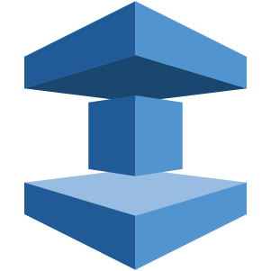
* It is a web service that makes it easy to set up, manage and scale a distributed cache-in environment in the cloud.
* **Amazon Redshift**



Amazon Redshift is a fully managed petabyte-scale data warehouse service in the cloud.

**Networking**

Networking and Content Delivery

* Amazon VPC
* Amazon CloudFront
* Amazon Route 53
* AWS Private Link
* AWS Direct Connect
* AWS Global Accelerator
* Amazon API Gateway
* AWS Transit Gateway
* AWS App Mesh
* AWS Cloud Map
* Elastic Load Balancing

**VPC AWS**



Amazon VPC lets you launch AWS resources in a virtual network that you define. It closely resembles a traditional network that you’d operate in your data centre.

* Amazon Virtual Private Cloud (VPC) helps a firm or a user by providing virtual cloud space for integrating the business.
* With AWS VPC one can completely monitor virtual networking environment, including the selection of your own IP address range, the creation of subnets, and configuration of route tables and network gateways these features helps a lot to integrate businesses.
* Amazon VPC allows you to logically analyse the section of Amazon Cloud where one can launch AWS Resources in the virtual network.
* To provide secure and easy access fourth and sixth revision to the Internet Protocol can be used.
* VPC in AWS as a logical container that separates resources you create from other customers within the Amazon Cloud. It is you defining a network of your own within Amazon.

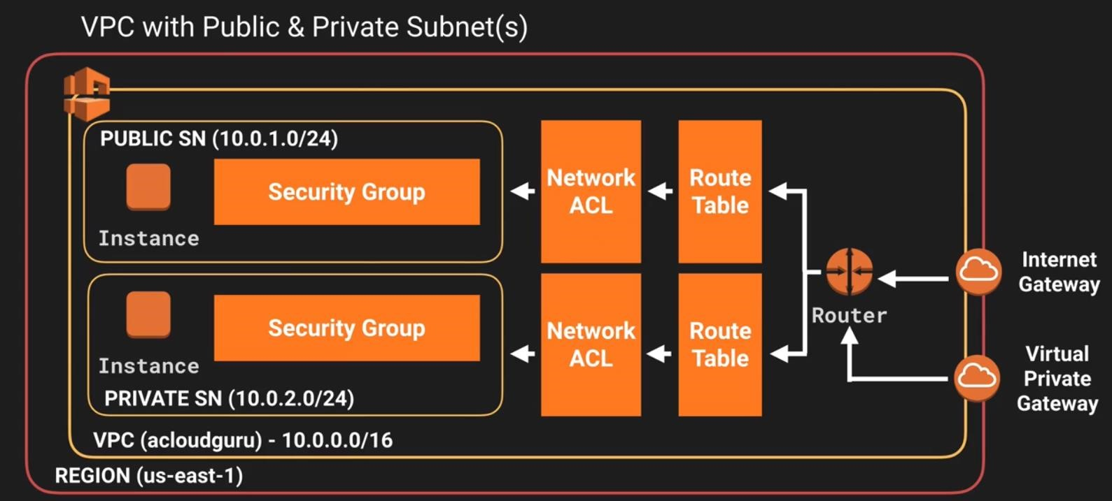

Subnet and Its Utility

**Subnets are like breaking a large network into sub-networks**. Maintaining a smaller network is easy as compared to maintaining a large network.

What Is Route Table?

Route table can be understood as a **table that contains rules for routing traffic within and outside a subnet**. The route table is also used to add Internet Gateway to the subnet. There can be multiple route tables in a VPC.

What Is Internet Gateway?

**Internet Gateway allows instance to connect to the internet**. It allows the user to make the subnet pubic by providing a route to the internet. With the help of Internet Gateway, an instance can access the internet and the resources outside instance can access the instance.

NAT - Network Address Translation.

**What is NAT?**

NAT is designed for IP address conservation. It enables private IP networks that use unregistered IP addresses to connect to the Internet.

**How does NAT work?**

NAT allows a single device, such as a router, to act as an agent between the Internet and a local network, which means a single unique IP address is required to represent an entire group of computers to public network i.e Outside of their Network.

**What is NAT Instance?**

NAT instance enable instances in the private subnet to initiate outbound traffic to the Internet but prevent the instances from receiving inbound traffic initiated by someone on the Internet.

Note: NAT Instance is a legacy, you can use NAT Gateway **What is NAT Gateway?**

**NAT Gateway is a managed NAT service that provides better availability, higher bandwidth, and requires less administrative effort.**

* **AWS Direct Connect**



It helps you establish a private connection between your premises and AWS, therefore giving better network performance and throughput than an Internet based connection.

* **Amazon Route 53**
* 

Route 53 is a highly scalable and highly available Domain Name System by Amazon AWS. The name is in reference to the TCP and UDP’s port 53 where DNS requests are addressed.

* AWS Route 53 is a domain name system. Domain name system translates human-readable domain name such as **www.amazon.com** to machine-readable IP address such as 192.0.2.44. Amazon Route 53

connects the request of users to the system running in AWS. This system includes **Amazon**

**EC2** instances, **Elastic Load Balancing** load balancers, or **Amazon S3** buckets. Moreover, it can connect the user infrastructure outside of AWS. Amazon Route 53 is totally compatible with IPv6. It is designed to boost business in a reliable and cost-effective way. AWS Route 53 answers all the queries with the help of the global network of DNS servers.

Queries of the domain are sent to the nearest DNS Server and thus it answers with the best possible performance. With the help of **AWS management console** or easy-to-use API, one can create and manage the public DNS. AWS Route 53 also helps us to register an available domain name. It helps in a way such that the person has to pay only for the management of domains, and the registered domains in AWS. • **Management Tools**

* **Amazon CloudWatch**



It is a monitoring tool by AWS which is used to keep a track on the AWS resources and the applications you run on Amazon AWS.

# Amazon CloudWatch

Amazon CloudWatch is a monitoring and management service built for developers, system operators, site reliability engineers (SRE), and IT managers. CloudWatch provides you with data and actionable insights to monitor your applications, understand and respond to system-wide performance changes, optimize resource utilization, and get a unified view of operational health. CloudWatch collects monitoring and operational data in the form of logs, metrics, and events, providing you with a unified view of AWS resources, applications and services that run on AWS, and on-premises servers. You can use CloudWatch to set high resolution alarms, visualize logs and metrics side by side, take automated actions, troubleshoot issues, and discover insights to optimize your applications, and ensure they are running smoothly.

With Amazon CloudWatch, it is easy to get started. There is no up-front commitment or minimum fee; you simply pay for what you use. You will be charged at the end of the month for what you use.

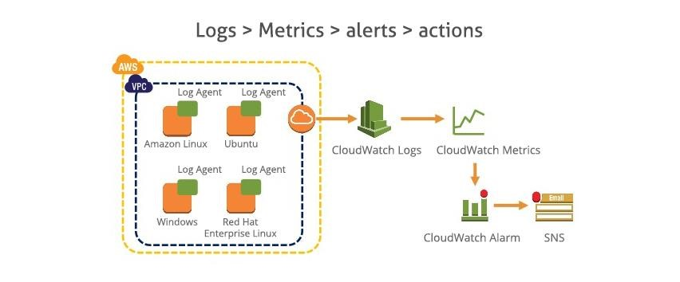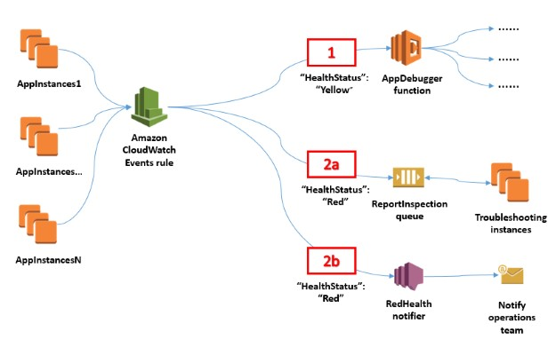

* **AWS CloudFormation**
* 

It is a service which helps you setup and model your Amazon AWS resources so that you can spend less time managing these resources and more time focusing on the development.

* **AWS CloudTrail**



AWS CloudTrail is a logging service which records the API calls to your Amazon AWS account and delivers them to you.

* **AWS Command Line Tool**
* 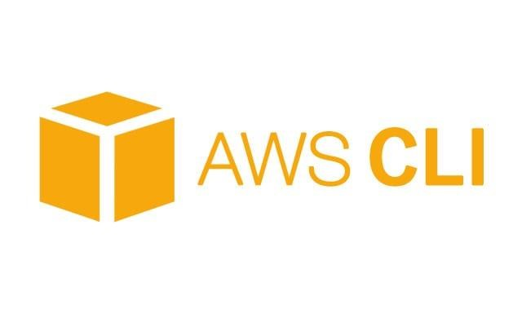

It is an all in one tool to manage all your AWS services, by downloading and configuring only one tool you can manage all the AWS services through the command line.

* **AWS OpsWorks**



It is a configuration management tool that helps configure and operate applications of all size and shapes using Chef.

* **Trusted Advisor**
* 

Trusted Advisor is a customized cloud monitoring tool, that analyzes your AWS environment and gives insights on the expense, performance improvement, security gaps and reliability.

* **Security and Identity**

**AWS security services**

The services covered within this learning path are as follows:

* AWS Identity & Access Management (IAM)
* AWS Key Management Service (KMS)
* AWS CloudHSM
* AWS WAF
* AWS CloudTrail
* Amazon Inspector
* AWS Config •

o **AWS Identity and Access Management(IAM)**



It is an AWS service that helps you control access to your AWS resources for your users.

# Identity and Access Management in(IAM)

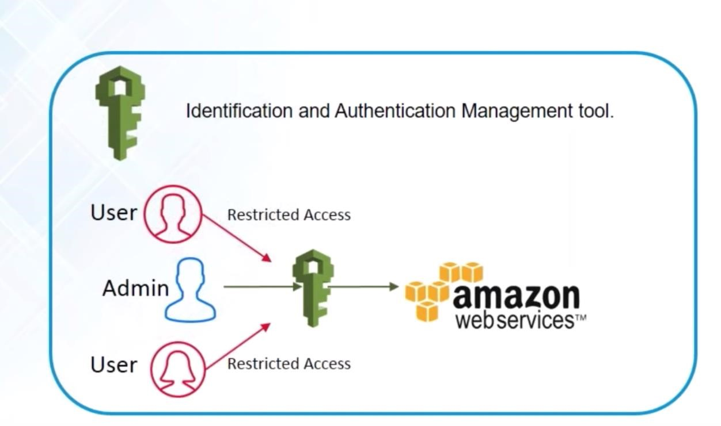

The AWS IAM enables the user to securely control access to AWS services and resources for the users. IAM enables user to create and manage users in AWS, and it also enables the user to grant access to AWS resources for users managed outside the AWS in the corporate directory. IAM enables identity federation between the user’s corporate directory and AWS services. This enables the user to use existing corporate identities to grant secure and direct access to AWS resources, such as S3 buckets, without creating a new AWS identity for those users.

The biggest advantage of IAM is that it is free. But if users launch EC2 it will be charged.

**AWS Key Management Service**

o 

It is a managed service that helps you create and control encryption keys which is used to encrypt your data, and uses Hardware Security Modules to protect the security of your keys.

**Application Services**

**# Application Integration**

* Step Functions
* Amazon MQ
* Simple Notification Service
* Simple Queue Service
* SWF

* **Amazon SES**



It is a cost effective emailing service which is built on the scalable and reliable infrastructure of Amazon.com

**Amazon SES**

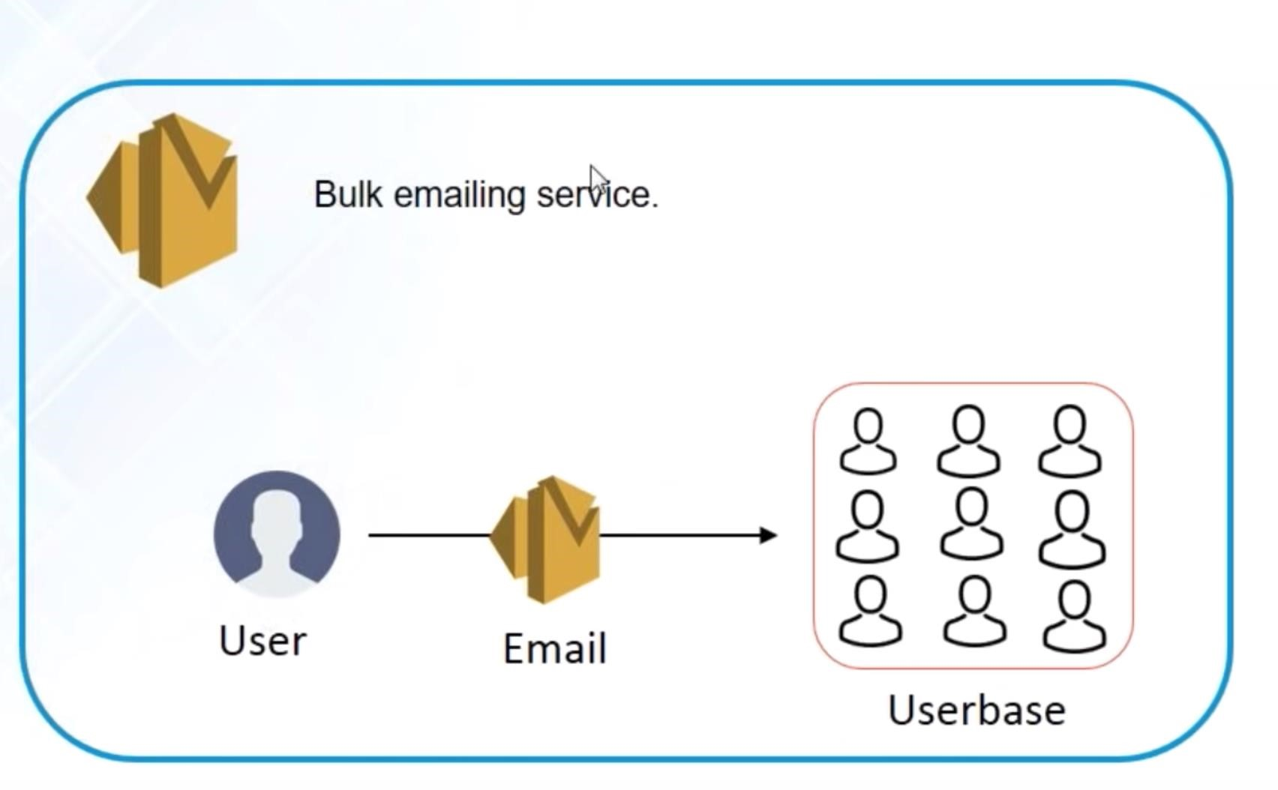

**What is Amazon SES?**

Amazon SES (Simple Email Service) is a service which sends an email regarding marketing, transaction, and notifications. It is suitable for small as well as large industries as the cost is less and it is reliable. Amazon SES can be directly integrated to the existing application with the help of SMTP Interface and Amazon SDK. Email sending capabilities can also be introduced in Amazon SES such as ticketing system and email clients.

Building a large-scale email answer is a complex and expensive challenge for a business: you’ve got to make your infrastructure, assemble your network, warm up your IP addresses and shield your sender name. Several thirdparty email solutions need contract negotiations and important up-front prices.

* **Amazon SNS**
* 

It is a web service offered by AWS that manages the delivery of messages to subscribed endpoints or clients.

# Simple Notification Service

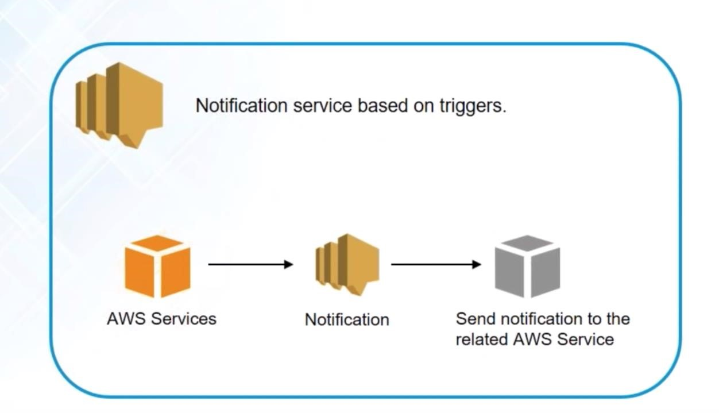

**What is SNS?**

* SNS stands for Simple Notification Service. o It is a web service which makes it easy to set up, operate, and send a notification from the cloud.
* It provides developers with the highly scalable, cost-effective, and flexible capability to publish messages from an application and sends them to other applications.
* It is a way of sending messages. When you are using AutoScaling, it triggers an SNS service which will email you that "your EC2 instance is growing".
* SNS can also send the messages to devices by sending push notifications to Apple, Google, Fire OS, and Windows devices, as well as Android devices in China with Baidu Cloud Push.
* Besides sending the push notifications to the mobile devices, Amazon SNS sends the notifications through SMS or email to an Amazon Simple Queue Service (SQS), or to an HTTP endpoint.
* SNS notifications can also trigger the Lambda function. When a message is published to an SNS topic that has a Lambda function associated with it, Lambda function is invoked with the payload of the message. Therefore, we can say that the Lambda function is invoked with a message payload as an input parameter and manipulate the information in the message and then sends the message to other SNS topics or other AWS services.
* Amazon SNS allows you to group multiple recipients using topics where the topic is a logical access point that sends the identical copies of the same message to the subscribe recipients.
* Amazon SNS supports multiple endpoint types. For example, you can group together IOS, Android and SMS recipients. Once you publish the message to the topic, SNS delivers the formatted copies of your message to the subscribers.
* To prevent the loss of data, all messages published to SNS are stored redundantly across multiple availability zones.

**SNS Publishers and Subscribers**

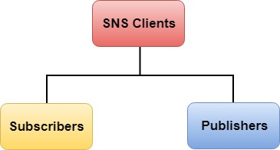

Amazon SNS is a web service that manages sending messages to the subscribing endpoint. There are two clients of SNS:

* Subscribers o Publishers

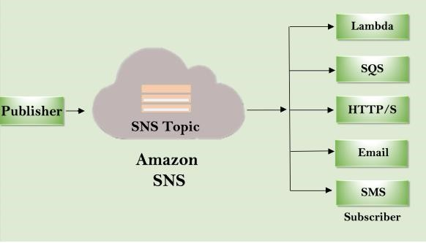

# Publishers

Publishers are also known as producers that produce and send the message to the SNS which is a logical access point.

# Subscribers

Subscribers such as web servers, email addresses, Amazon SQS queues, AWS Lambda functions receive the message or notification from the SNS over one of the supported protocols (Amazon SQS, email, Lambda, HTTP, SMS). o **Amazon SQS**



1. What is Amazon SQS (Simple Queue Service)?

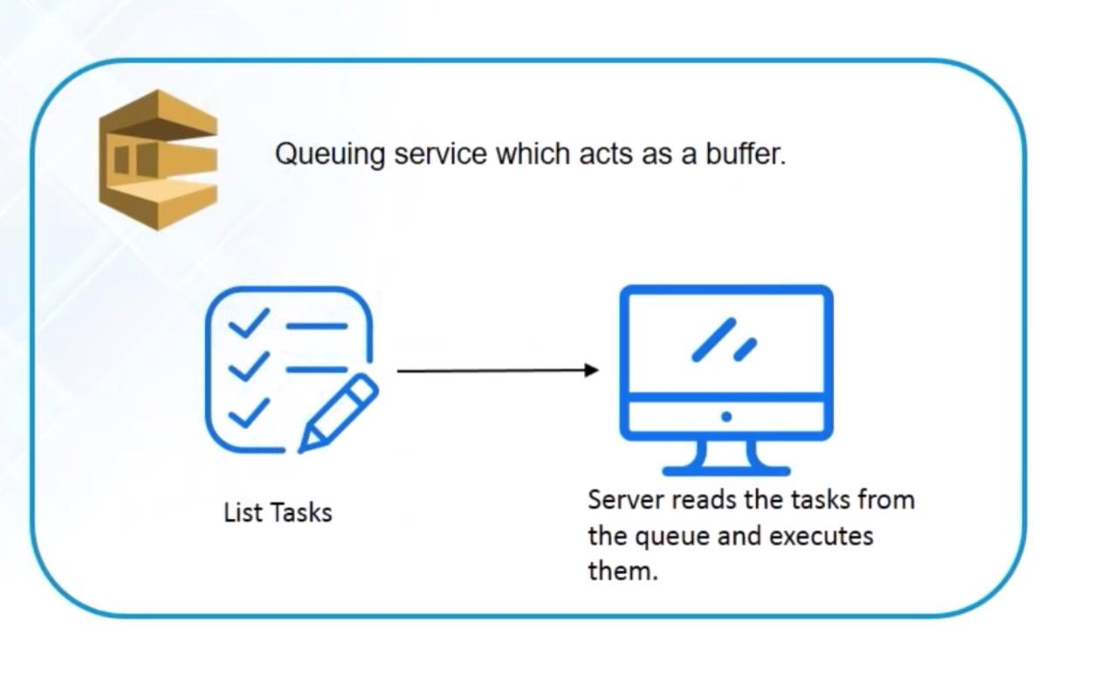

1. AWS SQS (Amazon Simple Queue Service) is a service which helps to align the message. Moreover, it also helps to enable the user to separate and scale microservices, distributed system, and serverless applications.
2. Amazon SQS makes it easy to manage the operating message-oriented middleware and enhances the developers to focus on their work.
3. Amazon Simple Queue Service works at any volume without losing the message or requiring other services to be available.
4. It helps to send, store, and receive messages between software components. AWS SQS can start with the help of the tools such as Amazon Console, command line interface, and SDK.

In Amazon SQS there are two types of queues which are

* Standard Queue : Standard queue offers at least one delivery and maximum throughput

Standard Queue

* It has a benefit of supporting an ample amount of transactions per second per API action.
* As the message is delivered on at a time but at the same time, it delivers more than one copy of a message.
* It may happen that the message delivered is in the different order from the source in which they were sent.

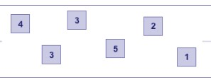

* AWS SQS FIFO:The FIFO queues guarantee that the processed message takes place only once in the first in first out basis.
* It has a high throughput which can send 300 messages per second which include 300 send, receive, and delete operation per second.
* The message is not duplicated it is stored with the customer until and unless customer deletes it.
* The messages are treated in first in first out order as the message sent and received is strictly preserved.

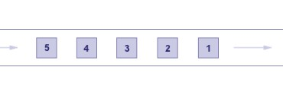

**Q1) What is AWS?**

Answer:AWS stands for Amazon Web Services. AWS is a platform that provides on-demand resources for hosting web services, storage, networking, databases and other resources over the internet with a pay-as-you-go pricing.

**Q2) What are the components of AWS?**

Answer:EC2 – Elastic Compute Cloud, S3 – Simple Storage Service, Route53, EBS – Elastic Block Store, Cloudwatch, Key-Paris are few of the components of AWS.

**Q3) What are key-pairs?**

Answer:Key-pairs are secure login information for your instances/virtual machines. To connect to the instances we use key-pairs that contain a public-key and private-key.

**Q4) What is S3?**

Answer:S3 stands for Simple Storage Service. It is a storage service that provides an interface that you can use to store any amount of data, at any time, from anywhere in the world. With S3 you pay only for what you use and the payment model is pay-as-you-go.

**Q5) What are the pricing models for EC2instances?**

Answer:The different pricing model for EC2 instances are as below,

* On-demand
* Reserved
* Spot
* Scheduled
* Dedicated

**Q6) What are the types of volumes for EC2 instances?**

Answer:

* There are two types of volumes,
* Instance store volumes
* EBS – Elastic Block Stores

**Q7) What are EBS volumes?**

Answer:EBS stands for Elastic Block Stores. They are persistent volumes that you can attach to the instances. With EBS volumes, your data will be preserved even when you stop your instances, unlike your instance store volumes where the data is deleted when you stop the instances.

**Q8) What are the types of volumes in EBS?**

Answer:Following are the types of volumes in EBS,

* General purpose
* Provisioned IOPS
* Magnetic
* Cold HDD
* Throughput optimized

**Q9) What are the different types of instances?**

Answer: Following are the types of instances,

* General purpose
* Computer Optimized
* Storage Optimized
* Memory Optimized
* Accelerated Computing

**Q10) What is an auto-scaling and what are the components?**

Answer: Auto scaling allows you to automatically scale-up and scale-down the number of instances depending on the CPU utilization or memory utilization. There are 2 components in Auto scaling, they are Auto-scaling groups and Launch Configuration.

**Q11) What are reserved instances?**

Answer: Reserved instances are the instance that you can reserve a fixed capacity of EC2 instances. In reserved instances you will have to get into a contract of 1 year or 3 years.

**Q12)What is an AMI?**

Answer: AMI stands for Amazon Machine Image. AMI is a template that contains the software configurations, launch permission and a block device mapping that specifies the volume to attach to the instance when it is launched.

**Q13) What is an EIP?**

EIP (**Elastic IP address**) is a service provided by an EC2 instance. It is basically a static IP address attached to an EC2 instance. This address is associated with your AWS account not with an EC2 instance. You can also disassociate your EIP address from your EC2 instance and map it to another EC2 instance in your AWS account.

**Let's understand the concept of EIP through an example:**

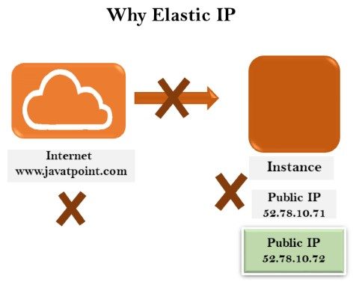

Suppose we consider the website www.javatpoint.com points to the instance which has a public IP address. When instance is restarted, then AWS takes another public IP address from the pool and the previous public IP address is no longer valid. Due to this reason, the original link is no longer available between the website and EC2 instance. To overcome from such situation, Elastic IP address or static address is used which does not change.

Answer: EIP stands for Elastic IP address. It is designed for dynamic cloud computing. When you want to have a static IP address for your instances when you stop and restart your instances, you will be using EIP address.

**Q14) What is Cloudwatch?**

Answer: Cloudwatch is a monitoring tool that you can use to monitor your various AWS resources. Like health check, network, Application, etc.

**Q15) What are the types in cloudwatch?**

Answer: There are 2 types in cloudwatch. Basic monitoring and detailed monitoring. Basic monitoring is free and detailed monitoring is chargeable.

**Q16) What are the cloudwatch metrics that are available for EC2 instances?**

Answer: Diskreads, Diskwrites, CPU utilization, networkpacketsIn, networkpacketsOut, networkIn, networkOut, CPUCreditUsage, CPUCreditBalance.

**Q17) What is the minimum and maximum size of individual objects that you can store in S3**

Answer: The minimum size of individual objects that you can store in S3 is 0 bytes and the maximum bytes that you can store for individual objects is 5TB.

**Q18) What are the different storage classes in S3?**

Answer: Following are the types of storage classes in S3,

* Standard frequently accessed
* Standard infrequently accessed • One-zone infrequently accessed.
* Glacier
* RRS – reduced redundancy storage

**Q19) What is the default storage class in S3?**

Answer: The default storage class in S3 in Standard frequently accessed.

**Q20) What is glacier?**

Answer: Glacier is the back up or archival tool that you use to back up your data in S3.

**Q21) How can you secure the access to your S3 bucket?**

Answer: There are two ways that you can control the access to your S3 buckets,

* ACL – Access Control List
* Bucket polices

**Q22) How can you encrypt data in S3?**

Answer: You can encrypt the data by using the below methods,

* Server Side Encryption – S3 (AES 256 encryption)
* Server Side Encryption – KMS (Key management Service)
* Server Side Encryption – C (Client Side)

**Q23) What are the parameters for S3 pricing?**

Answer: The pricing model for S3 is as below,

* Storage used
* Number of requests you make
* Storage management
* Data transfer
* Transfer acceleration

**Q24) What is the pre-requisite to work with Cross region replication in S3?**

Answer: You need to enable versioning on both source bucket and destination to work with cross region replication. Also both the source and destination bucket should be in different region.

**Q25) What are roles?**

Answer: Roles are used to provide permissions to entities that you trust within your AWS account. Roles are users in another account. Roles are similar to users but with roles you do not need to create any username and password to work with the resources.

**Q26) What are policies and what are the types of policies?**

Answer: Policies are permissions that you can attach to the users that you create. These policies will contain that access that you have provided to the users that you have created. There are 2 types of policies.

* Managed policies
* Inline policies

**Q27) What is cloudfront?**

Answer: Cloudfront is an AWS web service that provided businesses and application developers an easy and efficient way to distribute their content with low latency and high data transfer speeds. Cloudfront is content delivery network of AWS.

**Q28) What are edge locations?**

Answer: Edge location is the place where the contents will be cached. When a user tries to access some content, the content will be searched in the edge location. If it is not available then the content will be made available from the origin location and a copy will be stored in the edge location.

**Q29) What is the maximum individual archive that you can store in glacier?**

Answer: You can store a maximum individual archive of upto 40 TB.

**Q30) What is VPC?**

Answer: VPC stands for Virtual Private Cloud. VPC allows you to easily customize your networking configuration. VPC is a network that is logically isolated from other network in the cloud. It allows you to have your own IP address range, subnets, internet gateways, NAT gateways and security groups.

**Q31) What is VPC peering connection?**

Answer: VPC peering connection allows you to connect 1 VPC with another VPC. Instances in these VPC behave as if they are in the same network.

**Q32) What are NAT gateways?**

Answer: NAT stands for Network Address Translation. NAT gateways enables instances in a private subnet to connect to the internet but prevent the internet from initiating a connection with those instances.

**Q33) How can you control the security to your VPC?**

Answer: You can use security groups and NACL (Network Access Control List) to control the security to your

VPC.

**Q34) What are the different types of storage gateway?**

Answer: Following are the types of storage gateway.

* File gateway
* Volume gateway
* Tape gateway

**Q35) What is a snowball?**

Answer: Snowball is a data transport solution that used source appliances to transfer large amounts of data into and out of AWS. Using snowball, you can move huge amount of data from one place to another which reduces your network costs, long transfer times and also provides better security.

**Q36) What are the database types in RDS?**

Answer: Following are the types of databases in RDS,

* Aurora
* Oracle
* MYSQL server
* Postgresql
* MariaDB
* SQL server

**Q37) What is a redshift?**

Answer: Amazon redshift is a data warehouse product. It is a fast and powerful, fully managed, petabyte scale data warehouse service in the cloud.

Q38) What is SNS?

Answer: SNS stands for Simple Notification Service. SNS is a web service that makes it easy to notifications from the cloud. You can set up SNS to receive email notification or message notification.

**Q39) What are the types of routing polices in route53?**

Answer: Following are the types of routing policies in route53,

* Simple routing
* Latency routing
* Failover routing
* Geolocation routing
* Weighted routing
* Multivalue answer

**Q40) What is the maximum size of messages in SQS?**

Answer: The maximum size of messages in SQS is 256 KB.

**Q41) What are the types of queues in SQS?**

Answer: There are 2 types of queues in SQS.

* Standard queue
* FIFO (First In First Out)

**Q42) What is multi-AZ RDS?**

Answer: Multi-AZ (Availability Zone) RDS allows you to have a replica of your production database in another availability zone. Multi-AZ (Availability Zone) database is used for disaster recovery. You will have an exact copy of your database. So when your primary database goes down, your application will automatically failover to the standby database.

**Q43) What are the types of backups in RDS database?**

Answer: There are 2 types of backups in RDS database.

* Automated backups
* Manual backups which are known as snapshots.

**Q44) What is the difference between security groups and network access control list?**

Answer:

|  |  |
| --- | --- |
| Security Groups | Network access control list |
| Can control the access at the instance level | Can control access at the subnet level |
| Can add rules for “allow” only | Can add rules for both “allow” and “deny” |
| Evaluates all rules before allowing the traffic | Rules are processed in order number when allowing traffic. |
| Can assign unlimited number of security groups | Can assign upto 5 security groups. |
| Statefull filtering Stateless filtering | |

**Q45) What are the types of load balancers in EC2?**

Answer: There are 3 types of load balancers,

* Application load balancer
* Network load balancer
* Classic load balancer

**Q46) What is and ELB?**

Answer: ELB stands for Elastic Load balancing. ELB automatically distributes the incoming application traffic or network traffic across multiple targets like EC2, containers, IP addresses.

**Q47) What are the two types of access that you can provide when you are creating users?**

Answer: Following are the two types of access that you can create.

* Programmatic access
* Console access

**Q48) What are the benefits of auto scaling?**

Answer: Following are the benefits of auto scaling

* Better fault tolerance
* Better availability
* Better cost management

**Q49) What are security groups?**

Answer: Security groups acts as a firewall that contains the traffic for one or more instances. You can associate one or more security groups to your instances when you launch then. You can add rules to each security group that allow traffic to and from its associated instances. You can modify the rules of a security group at any time, the new rules are automatically and immediately applied to all the instances that are associated with the security group **Q50) What are shared AMI’s?**

Answer: Shared AMI’s are the AMI that are created by other developed and made available for other developed to use.

**Q51)What is the difference between the classic load balancer and application load balancer?**

Answer: Dynamic port mapping, multiple port multiple listeners is used in Application Load Balancer, One port one listener is achieved via Classic Load Balancer

**Q52) By default how many Ip address does aws reserve in a subnet?**

Answer: 5

**Q53) What is meant by subnet?**

Answer: A large section of IP Address divided in to chunks are known as subnets  **Q54) How can you convert a public subnet to private subnet?**

Answer: Remove IGW & add NAT Gateway, Associate subnet in Private route table  **Q55) Is it possible to reduce a ebs volume?**

Answer: no it’s not possible, we can increase it but not reduce them  **Q56) What is the use of elastic ip are they charged by AWS?**

Answer: These are ipv4 address which are used to connect the instance from internet, they are charged if the instances are not attached to it

**Q57) One of my s3 is bucket is deleted but i need to restore is there any possible way?**

Answer: If versioning is enabled we can easily restore them

**Q58) When I try to launch an ec2 instance i am getting Service limit exceed, how to fix the issue?**

Answer: By default AWS offer service limit of 20 running instances per region, to fix the issue we need to contact AWS support to increase the limit based on the requirement

**Q59) I need to modify the ebs volumes in Linux and windows is it possible**

Answer: yes its possible from console use modify volumes in section give the size u need then for windows go to disk management for Linux mount it to achieve the modification

**Q60) Is it possible to stop a RDS instance, how can I do that?**

Answer: Yes it’s possible to stop rds. Instance which are non-production and non multi AZ’s  **Q61) What is meant by parameter groups in rds. And what is the use of it?**

Answer: Since RDS is a managed service AWS offers a wide set of parameter in RDS as parameter group which is modified as per requirement

**Q62) What is the use of tags and how they are useful?**

Answer: Tags are used for identification and grouping AWS Resources

**Q63) I am viewing an AWS Console but unable to launch the instance, I receive an IAM Error how can I rectify it?**

Answer: As AWS user I don’t have access to use it, I need to have permissions to use it further  **Q64) I don’t want my AWS Account id to be exposed to users how can I avoid it?**

Answer: In IAM console there is option as sign in url where I can rename my own account name with AWS account

**Q65) By default how many Elastic Ip address does AWS Offer?**

Answer: 5 elastic ip per region

**Q66) You are enabled sticky session with ELB. What does it do with your instance?**

Answer: Binds the user session with a specific instance

**Q67) Which type of load balancer makes routing decisions at either the transport layer or the** **Application layer and supports either EC2 or VPC.**

Answer: Classic Load Balancer

**Q68) Which is virtual network interface that you can attach to an instance in a VPC?**

Answer: Elastic Network Interface

**Q69) You have launched a Linux instance in AWS EC2. While configuring security group, you** **Have selected SSH, HTTP, HTTPS protocol. Why do we need to select SSH?**

Answer: To verify that there is a rule that allows traffic from EC2 Instance to your computer

**Q70) You have chosen a windows instance with Classic and you want to make some change to the** **Security group. How will these changes be effective?**

Answer: Changes are automatically applied to windows instances

**Q71) Load Balancer and DNS service comes under which type of cloud service?**

Answer: IAAS-Storage

**Q72) You have an EC2 instance that has an unencrypted volume. You want to create another**

**Encrypted volume from this unencrypted volume. Which of the following steps can achieve this?**

Answer: Create a snapshot of the unencrypted volume (applying encryption parameters), copy the. Snapshot and create a volume from the copied snapshot

**Q73) Where does the user specify the maximum number of instances with the auto scaling Commands?**

Answer: Auto scaling Launch Config

**Q74) Which are the types of AMI provided by AWS?**

Answer: Instance Store backed, EBS Backed

**Q75) After configuring ELB, you need to ensure that the user requests are always attached to a Single instance. What setting can you use?**

Answer: Sticky session

**Q76) When do I prefer to Provisioned IOPS over the Standard RDS storage?**

Answer:If you have do batch-oriented is workloads.

**Q77) If I am running on my DB Instance a Multi-AZ deployments, can I use to the stand by the DB Instance for read or write a operation along with to primary DB instance?**

Answer: Primary db instance does not working.

**Q78) Which the AWS services will you use to the collect and the process e-commerce data for the near by real-time analysis?**

Answer: Good of Amazon DynamoDB.

**Q79) A company is deploying the new two-tier an web application in AWS. The company has to limited on staff and the requires high availability, and the application requires to complex queries and table joins. Which configuration provides to the solution for company’s requirements?**

Answer: An web application provide on Amazon DynamoDB solution.

**Q80) Which the statement use to cases are suitable for Amazon DynamoDB?**

Answer:The storing metadata for the Amazon S3 objects& The Running of relational joins and complex an updates.

**Q81) Your application has to the retrieve on data from your user’s mobile take every 5 minutes and then data is stored in the DynamoDB, later every day at the particular time the data is an extracted into S3 on a per user basis and then your application is later on used to visualize the data to user. You are the asked to the optimize the architecture of the backend system can to lower cost, what would you recommend do?**

Answer: Introduce Amazon Elasticache to the cache reads from the Amazon DynamoDB table and to reduce the provisioned read throughput.

**Q82) You are running to website on EC2 instances can deployed across multiple Availability Zones with an Multi-AZ RDS MySQL Extra Large DB Instance etc. Then site performs a high number of the small reads and the write per second and the relies on the eventual consistency model. After the comprehensive tests you discover to that there is read contention on RDS MySQL. Which is the best approaches to the meet these requirements?**

Answer:The Deploy Elasti Cache in-memory cache is running in each availability zone and Then Increase the RDS MySQL Instance size and the Implement provisioned IOPS.

**Q83) An startup is running to a pilot deployment of around 100 sensors to the measure street noise and The air quality is urban areas for the 3 months. It was noted that every month to around the 4GB of sensor data are generated. The company uses to a load balanced take auto scaled layer of the EC2 instances and a RDS database with a 500 GB standard storage. The pilot was success and now they want to the deploy take atleast 100K sensors.let which to need the supported by backend. You need to the stored data for at least 2 years to an analyze it. Which setup of following would you be prefer?**

Answer: The Replace the RDS instance with an 6 node Redshift cluster with take 96TB of storage.

**Q84) Let to Suppose you have an application where do you have to render images and also do some of general computing. which service will be best fit your need?**

Answer:Used on Application Load Balancer.

**Q85) How will change the instance give type for the instances, which are the running in your applications tier and Then using Auto Scaling. Where will you change it from areas?**

Answer: Changed to Auto Scaling launch configuration areas.

**Q86) You have an content management system running on the Amazon EC2 instance that is the approaching 100% CPU of utilization. Which option will be reduce load on the Amazon EC2 instance?**

Answer: Let Create a load balancer, and Give register the Amazon EC2 instance with it.

**Q87) What does the Connection of draining do?**

Answer: The re-routes traffic from the instances which are to be updated (or) failed an health to check.

**Q88) When the instance is an unhealthy, it is do terminated and replaced with an new ones, which of the services does that?**

Answer: The survice make a fault tolerance.

**Q89) What are the life cycle to hooks used for the AutoScaling?**

Answer: They are used to the put an additional taken wait time to the scale in or scale out events.

Are You Interested in AWS Course ? Click here

**Q90) An user has to setup an Auto Scaling group. Due to some issue the group has to failed for launch a single instance for the more than 24 hours. What will be happen to the Auto Scaling in the condition?**

Answer: The auto Scaling will be suspend to the scaling process.

**Q91) You have an the EC2 Security Group with a several running to EC2 instances. You changed to the Security of Group rules to allow the inbound traffic on a new port and protocol, and then the launched a several new instances in the same of Security Group.Such the new rules apply?**

Answer:The Immediately to all the instances in security groups.

**Q92) To create an mirror make a image of your environment in another region for the disaster recoverys, which of the following AWS is resources do not need to be recreated in second region?**

Answer: May be the selected on Route 53 Record Sets.

**Q93) An customers wants to the captures all client connections to get information from his load balancers at an interval of 5 minutes only, which cal select option should he choose for his application?**

Answer: The condition should be Enable to AWS CloudTrail for the loadbalancers.

**Q94) Which of the services to you would not use to deploy an app?**

Answer: Lambda app not used on deploy.

**Q95) How do the Elastic Beanstalk can apply to updates?**

Answer: By a duplicate ready with a updates prepare before swapping.

**Q96) An created a key in the oregon region to encrypt of my data in North Virginia region for security purposes. I added to two users to the key and the external AWS accounts. I wanted to encrypt an the object in S3, so when I was tried, then key that I just created is not listed.What could be reason&solution?**

Answer:The Key should be working in the same region.

**Q97) As a company needs to monitor a read and write IOPS for the AWS MySQL RDS instances and then send real-time alerts to the operations of team. Which AWS services to can accomplish this?**

Answer:The monitoring on Amazon CloudWatch

Q98) The organization that is currently using the consolidated billing has to recently acquired to another company that already has a number of the AWS accounts. How could an Administrator to ensure that all the AWS accounts, from the both existing company and then acquired company, is billed to the single account?

Answer: All Invites take acquired the company’s AWS account to join existing the company’s of organization by using AWS Organizations.

**Q99) The user has created an the applications, which will be hosted on the EC2. The application makes calls to the Dynamo DB to fetch on certain data. The application using the DynamoDB SDK to connect with the EC2 instance. Which of respect to best practice for the security in this scenario?**

Answer: The user should be attach an IAM roles with the DynamoDB access to EC2 instance.

**Q100) You have an application are running on EC2 Instance, which will allow users to download the files from a private S3 bucket using the pre-assigned URL. Before generating to URL the Q101) application should be verify the existence of file in S3. How do the application use the AWS credentials to access S3 bucket securely?**

Answer:An Create an IAM role for the EC2 that allows list access to objects in S3 buckets. Launch to instance with this role, and retrieve an role’s credentials from EC2 Instance make metadata.

**Q101) You use the Amazon CloudWatch as your primary monitoring system for web application. After a recent to software deployment, your users are to getting Intermittent the 500 Internal Server to the Errors, when you using web application. You want to create the CloudWatch alarm, and notify the on-call engineer let when these occur. How can you accomplish the using the AWS services?**

Answer: An Create a CloudWatch get Logs to group and A define metric filters that assure capture 500 Internal

Servers should be Errors. Set a CloudWatch alarm on the metric and By Use of Amazon Simple to create a Notification Service to notify an the on-call engineers when prepare CloudWatch alarm is triggered.

**Q102) You are designing a multi-platform of web application for the AWS. The application will run on the EC2 instances and Till will be accessed from PCs, tablets and smart phones.Then Supported accessing a platforms are Windows, MACOS, IOS and Android. They Separate sticky sessions and SSL certificate took setups are required for the different platform types. Which do describes the most cost effective and Like performance efficient the architecture setup?**

Answer:Assign to multiple ELBs an EC2 instance or group of EC2 take instances running to common component of the web application, one ELB change for each platform type.Take Session will be stickiness and SSL termination are done for the ELBs.

**Q103) You are migrating to legacy client-server application for AWS. The application responds to a specific DNS visible domain (e.g. www.example.com) and server 2-tier architecture, with multiple application for the servers and the database server. Remote clients use to TCP to connect to the application of servers. The application servers need to know the IP address of clients in order to the function of properly and are currently taking of that information from TCP socket. A Multi-AZ RDS MySQL instance to will be used for database. During the migration you change the application code but you have file a change request. How do would you implement the architecture on the AWS in order to maximize scalability and high availability?**

Answer: File a change request to get implement of Proxy Protocol support in the application. Use of ELB with

TCP Listener and A Proxy Protocol enabled to distribute the load on two application servers in the different AZs.

**Q104) Your application currently is leverages AWS Auto Scaling to the grow and shrink as a load Increases/decreases and has been performing as well. Your marketing a team expects and steady ramp up in traffic to follow an upcoming campaign that will result in 20x growth in the traffic over 4 weeks. Your forecast for approximate number of the Amazon EC2 instances necessary to meet peak demand is 175. What should be you do avoid potential service disruptions during the ramp up traffic?**

Answer: Check the service limits in the Trusted Advisors and adjust as necessary, so that forecasted count remains within the limits.

**Q105) You have a web application running on the six Amazon EC2 instances, consuming about 45% of resources on the each instance. You are using the auto-scaling to make sure that a six instances are running at all times. The number of requests this application processes to consistent and does not experience to spikes. Then application are critical to your business and you want to high availability for at all times. You want to the load be distributed evenly has between all instances. You also want to between use same Amazon Machine Image (AMI) for all instances. Which are architectural choices should you make?**

Answer: Deploy to 3 EC2 instances in one of availability zone and 3 in another availability of zones and to use of Amazon Elastic is Load Balancer.

**Q106) You are the designing an application that a contains protected health information. Security and Then compliance requirements for your application mandate that all protected to health information in application use to encryption at rest and in the transit module. The application to uses an threetier architecture. where should data flows through the load balancers and is stored on the Amazon EBS volumes for the processing, and the results are stored in the Amazon S3 using a AWS SDK. Which of the options satisfy the security requirements?**

Answer: Use TCP load balancing on load balancer system, SSL termination on Amazon to create EC2 instances,

OS-level disk take encryption on Amazon EBS volumes, and The amazon S3 with server-side to encryption and Use the SSL termination on load balancers, an SSL listener on the Amazon to create EC2 instances, Amazon EBS encryption on the EBS volumes containing the PHI, and Amazon S3 with a server-side of encryption.

**Q107) An startup deploys its create photo-sharing site in a VPC. An elastic load balancer distributes to web traffic across two the subnets. Then the load balancer session to stickiness is configured to use of AWSgenerated session cookie, with a session TTL of the 5 minutes. The web server to change Auto Scaling group is configured as like min-size=4, max-size=4. The startup is the preparing for a public launchs, by running the load-testing software installed on the single Amazon Elastic Compute Cloud (EC2) instance to running in us-west-2a. After 60 minutes of load-testing, the web server logs of show the following:WEBSERVER LOGS | # of HTTP requests to from load-tester system | # of HTTP requests to from private on beta users || webserver #1 (subnet an us-west-2a): | 19,210 | 434 | webserver #2 (subnet an us-west-2a): | 21,790 | 490 || webserver #3 (subnet an us-west-2b): | 0 | 410 || webserver #4 (subnet an us-west-2b): | 0 | 428 |Which as recommendations can be help of ensure that load-testing HTTP requests are will evenly distributed across to four web servers?**

Answer:Result of cloud is re-configure the load-testing software to the re-resolve DNS for each web request.

**Q108) To serve the Web traffic for a popular product to your chief financial officer and IT director have purchased 10 m1.large heavy utilization of Reserved Instances (RIs) evenly put spread across two availability zones: Route 53 are used to deliver the traffic to on Elastic Load Balancer (ELB). After the several months, the product grows to even more popular and you need to additional capacity As a result, your company that purchases two c3.2xlarge medium utilization RIs You take register the two c3.2xlarge instances on with your ELB and quickly find that the ml of large instances at 100% of capacity and the c3.2xlarge instances have significant to capacity that’s can unused Which option is the most of cost effective and uses EC2 capacity most of effectively?**

Answer: To use a separate ELB for the each instance type and the distribute load to ELBs with a Route 53 weighted round of robin.

**Q109) An AWS customer are deploying an web application that is the composed of a front-end running on the Amazon EC2 and confidential data that are stored on the Amazon S3. The customer security policy is that all accessing operations to this sensitive data must authenticated and authorized by centralized access to management system that is operated by separate security team. In addition, the web application team that be owns and administers the EC2 web front-end instances are prohibited from having the any ability to access data that circumvents this centralized access to management system. Which are configurations will support these requirements?**

Answer:The configure to the web application get authenticate end-users against the centralized access on the management system. Have a web application provision trusted to users STS tokens an entitling the download of the approved data directly from a Amazon S3.

**Q110) A Enterprise customer is starting on their migration to the cloud, their main reason for the migrating is agility and they want to the make their internal Microsoft active directory available to the many applications running on AWS, this is so internal users for only have to remember one set of the credentials and as a central point of user take control for the leavers and joiners. How could they make their actions the directory secures and the highly available with minimal on-premises on infrastructure changes in the most cost and the time-efficient way?**

Answer: By Using a VPC, they could be create an the extension to their data center and to make use of resilient hardware IPSEC on tunnels, they could then have two domain consider to controller instances that are joined to the existing domain and reside within the different subnets in the different availability zones.

|  |  |  |
| --- | --- | --- |
|  | Enroll Now! |  |
| **Q111)What is Cloud Computing?** | | |

Answer:Cloud computing means it provides services to access programs, application, storage, network, server over the internet through browser or client side application on your PC, Laptop, Mobile by the end user without installing, updating and maintaining them.

**Q112)Why we go for Cloud Computing?**

Answer:

* Lower computing cost
* Improved Performance
* No IT Maintenance
* Business connectivity
* Easily upgraded
* Device Independent

**Q113)What are the deployment models using in Cloud?**

Answer:

* Private Cloud
* Public Cloud
* Hybrid cloud
* Community cloud 4

**Q114)Explain Cloud Service Models?**

Answer: SAAS (Software as a Service): It is software distribution model in which application are hosted by a vendor over the internet for the end user freeing from complex software and hardware management. (Ex: Google drive, drop box)

PAAS (Platform as a Service): It provides platform and environment to allow developers to build applications. It frees developers without going into the complexity of building and maintaining the infrastructure. (Ex: AWS Elastic Beanstalk, Windows Azure)

IAAS (Infrastructure as a Service): It provides virtualized computing resources over the internet like cpu, memory, switches, routers, firewall, Dns, Load balancer (Ex: Azure, AWS) **Q115)What are the advantage of Cloud Computing?**

Answer:

* Pay per use
* Scalability
* Elasticity
* High Availability
* Increase speed and Agility
* Go global in Minutes

**Q116)What is AWS?**

Answer: Amazon web service is a secure cloud services platform offering compute, power, database, storage, content delivery and other functionality to help business scale and grow.

AWS is fully on-demand

AWS is Flexibility, availability and Scalability

AWS is Elasticity: scale up and scale down as needed.

**Q117)What is mean by Region, Availability Zone and Edge Location?**

Answer: Region: An independent collection of AWS resources in a defined geography. A collection of Data centers (Availability zones). All availability zones in a region connected by high bandwidth.

Availability Zones: An Availability zone is a simply a data center. Designed as independent failure zone. High speed connectivity, Low latency.

Edge Locations: Edge location are the important part of AWS Infrastructure. Edge locations are CDN endpoints for cloud front to deliver content to end user with low latency **Q118)How to access AWS Platform?**

Answer:

* AWS Console
* AWS CLI (Command line interface)
* AWS SDK (Software Development Kit)

**Q119)What is EC2? What are the benefits in EC2?**

Amazon Elastic compute cloud is a web service that provides resizable compute capacity in the cloud. AWS EC2 provides scalable computing capacity in the AWS Cloud. These are the virtual servers also called as an instances.

We can use the instances pay per use basis.

Benefits:

* Easier and Faster
* Elastic and Scalable
* High Availability
* Cost-Effective

**Q120)What are the pricing models available in AWS EC2?**

Answer:

* On-Demand Instances
* Reserved Instances
* Spot Instances
* Dedicated Host

**Q121)What are the types using in AWS EC2?**

Answer:

* General Purpose
* Compute Optimized
* Memory optimized
* Storage Optimized
* Accelerated Computing (GPU Based)

**Q122)What is AMI? What are the types in AMI?**

Amazon machine image is a special type of virtual appliance that is used to create a virtual machine within the amazon Elastic compute cloud. AMI defines the initial software that will be in an instance when it is launched.

Types of AMI:

* Published by AWS
* AWS Marketplace
* Generated from existing instances
* Uploaded virtual server

**Q123)How to Addressing AWS EC2 instances?**

Answer:

* Public Domain name system (DNS) name: When you launch an instance AWS creates a DNS name that can be used to access the
* Public IP: A launched instance may also have a public ip address This IP address assigned from the address reserved by AWS and cannot be specified.
* Elastic IP: An Elastic IP Address is an address unique on the internet that you reserve independently and associate with Amazon EC2 instance. This IP Address persists until the customer release it and is not tried to **Q124)What is Security Group?**

Answer: AWS allows you to control traffic in and out of your instance through virtual firewall called Security groups. Security groups allow you to control traffic based on port, protocol and source/Destination.

**Q125)When your instance show retired state?**

Retired state only available in Reserved instances. Once the reserved instance reserving time (1 yr/3 yr) ends it shows Retired state.

**Q126)Scenario: My EC2 instance IP address change automatically while instance stop and start. What is the reason for that and explain solution?**

Answer:AWS assigned Public IP automatically but it’s change dynamically while stop and start. In that case we need to assign Elastic IP for that instance, once assigned it doesn’t change automatically.

**Q127)What is Elastic Beanstalk?**

AWS Elastic Beanstalk is the fastest and simplest way to get an application up and running on AWS. Developers can simply upload their code and the service automatically handle all the details such as resource provisioning, load balancing, Auto scaling and Monitoring.

**Q128)What is Amazon Lightsail?**

Answer:Lightsail designed to be the easiest way to launch and manage a virtual private server with AWS.Lightsail plans include everything you need to jumpstart your project a virtual machine, ssd based storage, data transfer, DNS Management and a static ip.

**Q129)What is EBS?**

Answer:Amazon EBS Provides persistent block level storage volumes for use with Amazon EC2 instances. Amazon EBS volume is automatically replicated with its availability zone to protect component failure offering high availability and durability. Amazon EBS volumes are available in a variety of types that differ in performance characteristics and Price.

**Q130)How to compare EBS Volumes?**

Answer: Magnetic Volume: Magnetic volumes have the lowest performance characteristics of all Amazon EBS volume types.

EBS Volume size: 1 GB to 1 TB Average IOPS: 100 IOPS Maximum throughput: 40-90 MB

General-Purpose SSD: General purpose SSD volumes offers cost-effective storage that is ideal for a broad range of workloads. General purpose SSD volumes are billed based on the amount of data space provisioned regardless of how much of data you actually store on the volume.

EBS Volume size: 1 GB to 16 TB Maximum IOPS: upto 10000 IOPS Maximum throughput: 160 MB

Provisioned IOPS SSD: Provisioned IOPS SSD volumes are designed to meet the needs of I/O intensive workloads, particularly database workloads that are sensitive to storage performance and consistency in random access I/O throughput. Provisioned IOPS SSD Volumes provide predictable, High performance.

EBS Volume size: 4 GB to 16 TB Maximum IOPS: upto 20000 IOPS Maximum throughput: 320 MB

**Q131)What is cold HDD and Throughput-optimized HDD?**

Answer: Cold HDD: Cold HDD volumes are designed for less frequently accessed workloads. These volumes are significantly less expensive than throughput-optimized HDD volumes.

EBS Volume size: 500 GB to 16 TB Maximum IOPS: 200 IOPS Maximum throughput: 250 MB

Throughput-Optimized HDD: Throughput-optimized HDD volumes are low cost HDD volumes designed for frequent access, throughput-intensive workloads such as big data, data warehouse.

EBS Volume size: 500 GB to 16 TB Maximum IOPS: 500 IOPS Maximum throughput: 500 MB **Q132)What is Amazon EBS-Optimized instances?**

Answer: Amazon EBS optimized instances to ensure that the Amazon EC2 instance is prepared to take advantage of the I/O of the Amazon EBS Volume. An amazon EBS-optimized instance uses an optimized configuration stack and provide additional dedicated capacity for Amazon EBS I/When you select Amazon EBS-optimized for an instance you pay an additional hourly charge for that instance.

**Q133)What is EBS Snapshot?**

Answer:

* It can back up the data on the EBS Volume. Snapshots are incremental backups.
* If this is your first snapshot it may take some time to create. Snapshots are point in time copies of volumes.

**Q134)How to connect EBS volume to multiple instance?**

Answer: We can’t able to connect EBS volume to multiple instance, but we can able to connect multiple EBS Volume to single instance.

**Q135)What are the virtualization types available in AWS?**

Answer: Hardware assisted Virtualization: HVM instances are presented with a fully virtualized set of hardware and they executing boot by executing master boot record of the root block device of the image. It is default Virtualization.

Para virtualization: This AMI boot with a special boot loader called PV-GRUB. The ability of the guest kernel to communicate directly with the hypervisor results in greater performance levels than other virtualization approaches but they cannot take advantage of hardware extensions such as networking, GPU etc. Its customized Virtualization image. Virtualization image can be used only for particular service.

**Q136)Differentiate Block storage and File storage?**

Answer:

Block Storage: Block storage operates at lower level, raw storage device level and manages data as a set of numbered, fixed size blocks.

File Storage: File storage operates at a higher level, the operating system level and manage data as a named hierarchy of files and folders.

**Q137)What are the advantage and disadvantage of EFS? Advantages:**

Answer:

* Fully managed service
* File system grows and shrinks automatically to petabytes
* Can support thousands of concurrent connections
* Multi AZ replication
* Throughput scales automatically to ensure consistent low latency Disadvantages:
* Not available in all region
* Cross region capability not available
* More complicated to provision compared to S3 and EBS

**Q138)what are the things we need to remember while creating s3 bucket?**

Answer:

* Amazon S3 and Bucket names are
* This means bucket names must be unique across all AWS
* Bucket names can contain upto 63 lowercase letters, numbers, hyphens and
* You can create and use multiple buckets
* You can have upto 100 per account by

**Q139)What are the storage class available in Amazon s3?**

Answer:

* Amazon S3 Standard
* Amazon S3 Standard-Infrequent Access
* Amazon S3 Reduced Redundancy Storage
* Amazon Glacier

**Q140)Explain Amazon s3 lifecycle rules?**

Answer: Amazon S3 lifecycle configuration rules, you can significantly reduce your storage costs by automatically transitioning data from one storage class to another or even automatically delete data after a period of time.

* Store backup data initially in Amazon S3 Standard
* After 30 days, transition to Amazon Standard IA
* After 90 days, transition to Amazon Glacier
* After 3 years, delete

**Q141)What is the relation between Amazon S3 and AWS KMS?**

Answer: To encrypt Amazon S3 data at rest, you can use several variations of Server-Side Encryption. Amazon S3 encrypts your data at the object level as it writes it to disks in its data centers and decrypt it for you when you access it’ll SSE performed by Amazon S3 and AWS Key Management Service (AWS KMS) uses the 256-bit Advanced Encryption Standard (AES).

**Q142)What is the function of cross region replication in Amazon S3?**

Answer: Cross region replication is a feature allows you asynchronously replicate all new objects in the source bucket in one AWS region to a target bucket in another region. To enable cross-region replication, versioning must be turned on for both source and destination buckets. Cross region replication is commonly used to reduce the latency required to access objects in Amazon S3 **Q143)How to create Encrypted EBS volume?**

Answer: You need to select Encrypt this volume option in Volume creation page. While creation a new master key will be created unless you select a master key that you created separately in the service. Amazon uses the AWS key management service (KMS) to handle key management.

**Q144)Explain stateful and Stateless firewall.**

Answer:

Stateful Firewall: A Security group is a virtual stateful firewall that controls inbound and outbound network traffic to AWS resources and Amazon EC2 instances. Operates at the instance level. It supports allow rules only. Return traffic is automatically allowed, regardless of any rules.

Stateless Firewall: A Network access control List (ACL) is a virtual stateless firewall on a subnet level. Supports allow rules and deny rules. Return traffic must be explicitly allowed by rules.

**Q145)What is NAT Instance and NAT Gateway?**

Answer:

NAT instance: A network address translation (NAT) instance is an Amazon Linux machine Image (AMI) that is designed to accept traffic from instances within a private subnet, translate the source IP address to the Public IP address of the NAT instance and forward the traffic to IWG.

NAT Gateway: A NAT gateway is an Amazon managed resources that is designed to operate just like a NAT instance but it is simpler to manage and highly available within an availability Zone. To allow instance within a private subnet to access internet resources through the IGW via a NAT gateway.

**Q146)What is VPC Peering?**

Answer: Amazon VPC peering connection is a networking connection between two amazon vpc’s that enables instances in either Amazon VPC to communicate with each other as if they are within the same network. You can create amazon VPC peering connection between your own Amazon VPC’s or Amazon VPC in another AWS account within a single region.

**Q147)What is MFA in AWS?**

Answer: Multi factor Authentication can add an extra layer of security to your infrastructure by adding a second method of authentication beyond just password or access key.

**Q148)What are the Authentication in AWS?**

Answer:

* User Name/Password
* Access Key
* Access Key/ Session Token

**Q149)What is Data warehouse in AWS?**

Data ware house is a central repository for data that can come from one or more sources. Organization typically use data warehouse to compile reports and search the database using highly complex queries. Data warehouse also typically updated on a batch schedule multiple times per day or per hour compared to an OLTP (Online Transaction Processing) relational database that can be updated thousands of times per second.

**Q150)What is mean by Multi-AZ in RDS?**

Answer: Multi AZ allows you to place a secondary copy of your database in another availability zone for disaster recovery purpose. Multi AZ deployments are available for all types of Amazon RDS Database engines. When you create s Multi-AZ DB instance a primary instance is created in one Availability Zone and a secondary instance is created by another Availability zone.

**Q151)What is Amazon Dynamo DB?**

Answer: Amazon Dynamo DB is fully managed NoSQL database service that provides fast and predictable performance with seamless scalability. Dynamo DB makes it simple and Cost effective to store and retrieve any amount of data.

**Q152)What is cloud formation?**

Answer: Cloud formation is a service which creates the AWS infrastructure using code. It helps to reduce time to manage resources. We can able to create our resources Quickly and faster.

**Q153)How to plan Auto scaling?**

Answer:

* Manual Scaling
* Scheduled Scaling
* Dynamic Scaling

**Q154)What is Auto Scaling group?**

Answer: Auto Scaling group is a collection of Amazon EC2 instances managed by the Auto scaling service. Each auto scaling group contains configuration options that control when auto scaling should launch new instance or terminate existing instance.

**Q155)Differentiate Basic and Detailed monitoring in cloud watch?**

Answer:

Basic Monitoring: Basic monitoring sends data points to Amazon cloud watch every five minutes for a limited number of preselected metrics at no charge.

Detailed Monitoring: Detailed monitoring sends data points to amazon CloudWatch every minute and allows data aggregation for an additional charge.

**Q156)What is the relationship between Route53 and Cloud front?**

Answer: In Cloud front we will deliver content to edge location wise so here we can use Route 53 for Content Delivery Network. Additionally, if you are using Amazon CloudFront you can configure Route 53 to route Internet traffic to those resources.

**Q157)What are the routing policies available in Amazon Route53?**

Answer:

* Simple
* Weighted
* Latency Based
* Failover
* Geolocation

**Q158)What is Amazon ElastiCache?**

Answer: Amazon ElastiCache is a web services that simplifies the setup and management of distributed in memory caching environment.

* Cost Effective
* High Performance
* Scalable Caching Environment
* Using Memcached or Redis Cache Engine

**Q159)What is SES, SQS and SNS?**

Answer: SES (Simple Email Service): SES is SMTP server provided by Amazon which is designed to send bulk mails to customers in a quick and cost-effective manner.SES does not allows to configure mail server.

SQS (Simple Queue Service): SQS is a fast, reliable and scalable, fully managed message queuing service.

Amazon SQS makes it simple and cost Effective. It’s temporary repository for messages to waiting for processing and acts as a buffer between the component producer and the consumer.

SNS (Simple Notification Service): SNS is a web service that coordinates and manages the delivery or sending of messages to recipients.

**Q160)How To Use Amazon Sqs? What Is Aws?**

Answer:Amazon Web Services is a secure cloud services stage, offering compute power, database storage, content delivery and other functionality to help industries scale and grow.

**Q161) What is the importance of buffer in AWS?**

Answer:low price – Consume only the amount of calculating, storage and other IT devices needed. No long-term assignation, minimum spend or up-front expenditure is required.

Elastic and Scalable – Quickly Rise and decrease resources to applications to satisfy customer demand and control costs. Avoid provisioning maintenance up-front for plans with variable consumption speeds or low lifetimes.

**Q162)What is the way to secure data for resounding in the cloud?**

Answer:

* Avoid storage sensitive material in the cloud. …
* Read the user contract to find out how your cloud service storing works. …
* Be serious about passwords. … • Encrypt. …
* Use an encrypted cloud service.

**Q163) Name The Several Layers Of Cloud Computing?**

Answer:Cloud computing can be damaged up into three main services: Software-as-a-Service (SaaS),

Infrastructure-as-a-Service (IaaS) and Platform-as-a-Service (PaaS). PaaS in the middle, and IaaS on the lowest **Q164) What Is Lambda edge In Aws?**

Answer:Lambda Edge lets you run Lambda functions to modify satisfied that Cloud Front delivers, executing the functions in AWS locations closer to the viewer. The functions run in response to Cloud Front events, without provisioning or managing server.

**Q165) Distinguish Between Scalability And Flexibility?**

Answer:Cloud computing offers industries flexibility and scalability when it comes to computing needs:

Flexibility. Cloud computing agrees your workers to be more flexible – both in and out of the workplace. Workers can access files using web-enabled devices such as smartphones, laptops and notebooks. In this way, cloud computing empowers the use of mobile technology.

One of the key assistances of using cloud computing is its scalability. Cloud computing allows your business to easily expensive or downscale your IT requests as and when required. For example, most cloud service workers will allow you to increase your existing resources to accommodate increased business needs or changes. This will allow you to support your commercial growth without exclusive changes to your present IT systems.

**Q166) What is IaaS?**

Answer:IaaS is a cloud service that runs services on “pay-for-what-you-use” basis

IaaS workers include Amazon Web Services, Microsoft Azure and Google Compute Engine

Users: IT Administrators **Q167) What is PaaS?**

Answer:PaaS runs cloud platforms and runtime environments to develop, test and manage software

Users: Software Developers **Q168) What is SaaS?**

Answer:In SaaS, cloud workers host and manage the software application on a pay-as-you-go pricing model

Users: End Customers

**Q169) Which Automation Gears Can Help With Spinup Services?**

Answer:The API tools can be used for spin up services and also for the written scripts. Persons scripts could be coded in Perl, bash or other languages of your preference. There is one more option that is flowery management and stipulating tools such as a dummy or improved descendant. A tool called Scalar can also be used and finally we can go with a controlled explanation like a Right scale. Which automation gears can help with pinup service.

**Q170) What Is an Ami? How Do I Build One?**

Answer:An Amazon Machine Image (AMI) explains the programs and settings that will be applied when you launch an EC2 instance. Once you have finished organizing the data, services, and submissions on your ArcGIS Server instance, you can save your work as a custom AMI stored in Amazon EC2. You can scale out your site by using this institution AMI to launch added instances

Use the following process to create your own AMI using the AWS Administration Console:

*Configure an EC2 example and its attached EBS volumes in the exact way you want them created in the custom AMI.

1. Log out of your instance, but do not stop or terminate it.
2. Log in to the AWS Management Console, display the EC2 page for your region, then click Instances.
3. Choose the instance from which you want to create a custom AMI.
4. Click Actions and click Create Image.
5. Type a name for Image Name that is easily identifiable to you and, optionally, input text for Image Description.
6. Click Create Image.

Read the message box that appears. To view the AMI standing, go to the AMIs page. Here you can see your AMI being created. It can take a though to create the AMI. Plan for at least 20 minutes, or slower if you’ve connected a lot of additional applications or data.

**Q171)What Are The Main Features Of Amazon Cloud Front?**

Answer:Amazon Cloud Front is a web service that speeds up delivery of your static and dynamic web content, such as .html, .css, .js, and image files, to your users.CloudFront delivers your content through a universal network of data centers called edge locations

**Q172)What Are The Features Of The Amazon Ec2 Service?**

Answer:Amazon Elastic Calculate Cloud (Amazon EC2) is a web service that provides secure, resizable compute capacity in the cloud. It is designed to make web-scale cloud calculating easier for designers. Amazon EC2’s simple web serviceinterface allows you to obtain and configure capacity with minimal friction.

**Q173)Explain Storage For Amazon Ec2 Instance.?**

Answer:An instance store is a provisional storing type located on disks that are physically attached to a host machine. … This article will present you to the AWS instance store storage type, compare it to AWS Elastic Block Storage (AWS EBS), and show you how to backup data stored on instance stores to AWS EBS

Amazon SQS is a message queue service used by scattered requests to exchange messages through a polling model, and can be used to decouple sending and receiving components

**Q174)When attached to an Amazon VPC which two components provide connectivity with external networks?**

Answer:

* Internet Gateway {IGW)
* Virtual Private Gateway (VGW)

**Q175)Which of the following are characteristics of Amazon VPC subnets?**

Answer:

* Each subnet maps to a single Availability Zone.
* By defaulting, all subnets can route between each other, whether they are private or public.

**Q176)How can you send request to Amazon S3?**

Answer:Every communication with Amazon S3 is either genuine or anonymous. Authentication is a process of validating the individuality of the requester trying to access an Amazon Web Services (AWS) product. Genuine requests must include a autograph value that authenticates the request sender. The autograph value is, in part, created from the requester’s AWS access keys (access key identification and secret access key).

**Q177)What is the best approach to anchor information for conveying in the cloud ?**

Answer:Backup Data Locally. A standout amongst the most vital interesting points while overseeing information is to guarantee that you have reinforcements for your information,

* Avoid Storing Sensitive Information. …
* Use Cloud Services that Encrypt Data. …
* Encrypt Your Data. …
* Install Anti-infection Software. … • Make Passwords Stronger. …
* Test the Security Measures in Place.

**Q178)What is AWS Certificate Manager ?**

Answer:AWS Certificate Manager is an administration that lets you effortlessly arrangement, oversee, and send open and private Secure Sockets Layer/Transport Layer Security (SSL/TLS) endorsements for use with AWS administrations and your inward associated assets. SSL/TLS declarations are utilized to anchor arrange interchanges and set up the character of sites over the Internet and additionally assets on private systems. AWS Certificate Manager expels the tedious manual procedure of obtaining, transferring, and reestablishing SSL/TLS endorsements.

**Q179)What is the AWS Key Management Service**

Answer:AWS Key Management Service (AWS KMS) is an overseen benefit that makes it simple for you to make and control the encryption keys used to scramble your information. … AWS KMS is additionally coordinated with AWS CloudTrail to give encryption key use logs to help meet your inspecting, administrative and consistence needs.

**Q180)**

**What is Amazon EMR ?**

Answer:Amazon Elastic MapReduce (EMR) is one such administration that gives completely oversaw facilitated Hadoop system over Amazon Elastic Compute Cloud (EC2).

**Q181)What is Amazon Kinesis Firehose ?**

Answer:Amazon Kinesis Data Firehose is the least demanding approach to dependably stack gushing information into information stores and examination devices. … It is a completely overseen benefit that consequently scales to coordinate the throughput of your information and requires no continuous organization **Q182)What Is Amazon CloudSearch and its highlights ?**

Answer:Amazon CloudSearch is a versatile cloud-based hunt benefit that frames some portion of Amazon Web

Services (AWS). CloudSearch is normally used to incorporate tweaked seek abilities into different applications.

As indicated by Amazon, engineers can set a pursuit application up and send it completely in under 60 minutes.

**Q183)Is it feasible for an EC2 exemplary occurrence to wind up an individual from a virtual private cloud?**

Answer:Amazon Virtual Private Cloud (Amazon VPC) empowers you to characterize a virtual system in your very own consistently disengaged zone inside the AWS cloud, known as a virtual private cloud (VPC). You can dispatch your Amazon EC2 assets, for example, occasions, into the subnets of your VPC. Your VPC nearly looks like a conventional system that you may work in your very own server farm, with the advantages of utilizing adaptable foundation from AWS. You can design your VPC; you can choose its IP address extend, make subnets, and arrange course tables, organize portals, and security settings. You can interface occurrences in your VPC to the web or to your own server farm

**Q184)Mention crafted by an Amazon VPC switch.**

Answer:VPCs and Subnets. A virtual private cloud (VPC) is a virtual system committed to your AWS account. It is consistently segregated from other virtual systems in the AWS Cloud. You can dispatch your AWS assets, for example, Amazon EC2 cases, into your VPC.

**Q185)How would one be able to associate a VPC to corporate server farm?**

Answer:AWS Direct Connect empowers you to safely associate your AWS condition to your on-premises server farm or office area over a standard 1 gigabit or 10 gigabit Ethernet fiber-optic association. AWS Direct Connect offers committed fast, low dormancy association, which sidesteps web access suppliers in your system way. An AWS Direct Connect area gives access to Amazon Web Services in the locale it is related with, and also access to different US areas. AWS Direct Connect enables you to consistently parcel the fiber-optic associations into numerous intelligent associations called Virtual Local Area Networks (VLAN). You can exploit these intelligent associations with enhance security, separate traffic, and accomplish consistence necessities.

**Q186)Is it conceivable to push off S3 with EC2 examples ?**

Answer:Truly, it very well may be pushed off for examples with root approaches upheld by local event stockpiling. By utilizing Amazon S3, engineers approach the comparative to a great degree versatile, reliable, quick, low-valued information stockpiling substructure that Amazon uses to follow its own overall system of sites.

So as to perform frameworks in the Amazon EC2 air, engineers utilize the instruments giving to stack their Amazon Machine Images (AMIs) into Amazon S3 and to exchange them between Amazon S3 and Amazon EC2.

Extra use case may be for sites facilitated on EC2 to stack their stationary substance from S3.

**Q187)What is the distinction between Amazon S3 and EBS ?**

Answer:EBS is for mounting straightforwardly onto EC2 server examples. S3 is Object Oriented Storage that isn’t continually waiting be gotten to (and is subsequently less expensive). There is then much less expensive AWS

Glacier which is for long haul stockpiling where you don’t generally hope to need to get to it, however wouldn’t have any desire to lose it.

There are then two principle kinds of EBS – HDD (Hard Disk Drives, i.e. attractive turning circles), which are genuinely ease back to access, and SSD, which are strong state drives which are excessively quick to get to, yet increasingly costly. • Finally, EBS can be purchased with or without Provisioned IOPS.

• Obviously these distinctions accompany related estimating contrasts, so it merits focusing on the distinctions and utilize the least expensive that conveys the execution you require.

**Q188)What do you comprehend by AWS?**

Answer:This is one of the generally asked AWS engineer inquiries questions. This inquiry checks your essential AWS learning so the appropriate response ought to be clear. Amazon Web Services (AWS) is a cloud benefit stage which offers figuring power, investigation, content conveyance, database stockpiling, sending and some different administrations to help you in your business development. These administrations are profoundly versatile, solid, secure, and cheap distributed computing administrations which are plot to cooperate and, applications in this manner made are further developed and escalade.

**Q189)Clarify the principle components of AWS?**

Answer:The principle components of AWS are:

Highway 53: Route53 is an exceptionally versatile DNS web benefit.

Basic Storage Service (S3): S3 is most generally utilized AWS stockpiling web benefit.

Straightforward E-mail Service (SES): SES is a facilitated value-based email benefit and enables one to smoothly send deliverable messages utilizing a RESTFUL API call or through an ordinary SMTP.

Personality and Access Management (IAM): IAM gives enhanced character and security the board for AWS account.

Versatile Compute Cloud (EC2): EC2 is an AWS biological community focal piece. It is in charge of giving onrequest and adaptable processing assets with a “pay as you go” estimating model.

Flexible Block Store (EBS): EBS offers consistent capacity arrangement that can be found in occurrences as a customary hard drive.

CloudWatch: CloudWatch enables the controller to viewpoint and accumulate key measurements and furthermore set a progression of cautions to be advised if there is any inconvenience.

This is among habitually asked AWS engineer inquiries questions. Simply find the questioner psyche and solution appropriately either with parts name or with the portrayal alongside.

**Q190)I’m not catching your meaning by AMI? What does it incorporate?**

Answer:You may run over at least one AMI related AWS engineer inquiries amid your AWS designer meet.

Along these lines, set yourself up with a decent learning of AMI.

AMI represents the term Amazon Machine Image. It’s an AWS format which gives the data (an application server, and working framework, and applications) required to play out the dispatch of an occasion. This AMI is the duplicate of the AMI that is running in the cloud as a virtual server. You can dispatch occurrences from the same number of various AMIs as you require. AMI comprises of the followings:

A pull volume format for a current example

Launch authorizations to figure out which AWS records will inspire the AMI so as to dispatch the occasions

Mapping for square gadget to compute the aggregate volume that will be appended to the example at the season of dispatch

**Q191) Is vertically scale is conceivable on Amazon occurrence?**

Answer:Indeed, vertically scale is conceivable on Amazon example.

This is one of the normal AWS engineer inquiries questions. In the event that the questioner is hoping to find a definite solution from you, clarify the system for vertical scaling.

**Q192)What is the association among AMI and Instance?**

Answer:Various sorts of examples can be propelled from one AMI. The sort of an occasion for the most part manages the equipment segments of the host PC that is utilized for the case. Each kind of occurrence has unmistakable registering and memory adequacy.

When an example is propelled, it gives a role as host and the client cooperation with it is same likewise with some other PC however we have a totally controlled access to our occurrences. AWS engineer inquiries questions may contain at least one AMI based inquiries, so set yourself up for the AMI theme exceptionally well.

**Q193)What is the distinction between Amazon S3 and EC2?**

Answer: The contrast between Amazon S3 and EC2 is given beneath:

Amazon S3

Amazon EC2

The significance of S3 is Simple Storage Service. The importance of EC2 is Elastic Compute Cloud.

It is only an information stockpiling administration which is utilized to store huge paired files. It is a cloud web benefit which is utilized to have the application made.

It isn’t required to run a server. It is sufficient to run a server.

It has a REST interface and utilizations secure HMAC-SHA1 validation keys. It is much the same as a tremendous PC machine which can deal with application like Python, PHP, Apache and some other database.

When you are going for an AWS designer meet, set yourself up with the ideas of Amazon S3 and EC2, and the distinction between them.

**Q194)What number of capacity alternatives are there for EC2 Instance?**

Answer:There are four stockpiling choices for Amazon EC2 Instance:

* Amazon EBS
* Amazon EC2 Instance Store
* Amazon S3
* Adding Storage

Amazon EC2 is the basic subject you may run over while experiencing AWS engineer inquiries questions. Get a careful learning of the EC2 occurrence and all the capacity alternatives for the EC2 case.

**Q195)What are the security best practices for Amazon Ec2 examples?**

Answer: There are various accepted procedures for anchoring Amazon EC2 occurrences that are pertinent whether occasions are running on-preface server farms or on virtual machines. How about we view some broad prescribed procedures:

Minimum Access: Make beyond any doubt that your EC2 example has controlled access to the case and in addition to the system. Offer access specialists just to the confided in substances.

Slightest Privilege: Follow the vital guideline of minimum benefit for cases and clients to play out the capacities.

Produce jobs with confined access for the occurrences.

Setup Management: Consider each EC2 occasion a design thing and use AWS arrangement the executives administrations to have a pattern for the setup of the occurrences as these administrations incorporate refreshed enemy of infection programming, security highlights and so forth.

Whatever be the activity job, you may go over security based AWS inquiries questions. Along these lines, motivate arranged with this inquiry to break the AWS designer meet.

**Q196)Clarify the highlights of Amazon EC2 administrations.**

Answer: Amazon EC2 administrations have following highlights:

* Virtual Computing Environments
* Proffers Persistent capacity volumes
* Firewall approving you to indicate the convention
* Pre-designed layouts
* Static IP address for dynamic Cloud Computing

**Q197)What is the system to send a demand to Amazon S3?**

Answer: Reply: There are 2 different ways to send a demand to Amazon S3 –

* Using REST API
* Using AWS SDK Wrapper Libraries, these wrapper libraries wrap the REST APIs for Amazon

**Q198)What is the default number of basins made in AWS?**

Answer**:**This is an extremely straightforward inquiry yet positions high among AWS engineer inquiries questions.

Answer this inquiry straightforwardly as the default number of pails made in each AWS account is 100.

**Q199)What is the motivation behind T2 examples?**

Answer:T2 cases are intended for

Providing moderate gauge execution

Higher execution as required by outstanding task at hand **Q200)What is the utilization of the cradle in AWS?**

Answer:This is among habitually asked AWS designer inquiries questions. Give the appropriate response in straightforward terms, the cradle is primarily used to oversee stack with the synchronization of different parts i.e. to make framework blame tolerant. Without support, segments don’t utilize any reasonable technique to get and process demands. Be that as it may, the cushion makes segments to work in a decent way and at a similar speed, hence results in quicker administrations.

**Q201)What happens when an Amazon EC2 occurrence is halted or ended?**

Answer:At the season of ceasing an Amazon EC2 case, a shutdown is performed in a typical way. From that point onward, the changes to the ceased state happen. Amid this, the majority of the Amazon EBS volumes are stayed joined to the case and the case can be begun whenever. The occurrence hours are not included when the occasion is the ceased state.

At the season of ending an Amazon EC2 case, a shutdown is performed in an ordinary way. Amid this, the erasure of the majority of the Amazon EBS volumes is performed. To stay away from this, the estimation of credit deleteOnTermination is set to false. On end, the occurrence additionally experiences cancellation, so the case can’t be begun once more.

**Q202)What are the mainstream DevOps devices?**

Answer:In an AWS DevOps Engineer talk with, this is the most widely recognized AWS inquiries for DevOps. To answer this inquiry, notice the well known DevOps apparatuses with the kind of hardware –

* Jenkins – Continuous Integration Tool
* Git – Version Control System Tool
* Nagios – Continuous Monitoring Tool
* Selenium – Continuous Testing Tool
* Docker – Containerization Tool
* Puppet, Chef, Ansible – Deployment and Configuration Administration Tools.

**Q203)What are IAM Roles and Policies, What is the difference between IAM Roles and Policies.**

Answer:Roles are for AWS services, Where we can assign permission of some AWS service to other Service.

Example – Giving S3 permission to EC2 to access S3 Bucket Contents.

Policies are for users and groups, Where we can assign permission to user’s and groups.

Example – Giving permission to user to access the S3 Buckets.

**Q204)What are the Defaults services we get when we create custom AWS VPC?**

Answer:

* Route Table
* Network ACL
* Security Group

**Q205)What is the Difference Between Public Subnet and Private Subnet ?**

Answer:Public Subnet will have Internet Gateway Attached to its associated Route Table and Subnet, Private

Subnet will not have the Internet Gateway Attached to its associated Route Table and Subnet

Public Subnet will have internet access and Private subnet will not have the internet access directly.

**Q206) How do you access the Ec2 which has private IP which is in private Subnet ?**

Answer: We can access using VPN if the VPN is configured into that Particular VPC where Ec2 is assigned to that VPC in the Subnet. We can access using other Ec2 which has the Public access.

**Q207)We have a custom VPC Configured and MYSQL Database server which is in Private Subnet and we need to update the MYSQL Database Server, What are the Option to do so.**

Answer:By using NAT Gateway in the VPC or Launch a NAT Instance ( Ec2) Configure or Attach the NAT Gateway in Public Subnet ( Which has Route Table attached to IGW) and attach it to the Route Table which is Already attached to the Private Subnet.

**Q208) What are the Difference Between Security Groups and Network ACL**

Answer:

**Security Groups**  **Network ACL**

|  |  |
| --- | --- |
| Attached to Ec2 instance | Attached to a subnet. |
| Stateful – Changes made in incoming rules is automatically applied to the outgoing rule | Stateless – Changes made in incoming rules is not applied to the outgoing rule |
| Blocking IP Address can’t be done | IP Address can be Blocked |
| Allow rules only, by default all rules are denied | Allow and Deny can be Used. |

**Q209)What are the Difference Between Route53 and ELB?**

Answer:Amazon Route 53 will handle DNS servers. Route 53 give you web interface through which the DNS can be managed using Route 53, it is possible to direct and failover traffic. This can be achieved by using DNS Routing Policy.

One more routing policy is Failover Routing policy. we set up a health check to monitor your application endpoints. If one of the endpoints is not available, Route 53 will automatically forward the traffic to other endpoint.

Elastic Load Balancing

ELB automatically scales depends on the demand, so sizing of the load balancers to handle more traffic effectively when it is not required.

**Q210)What are the DB engines which can be used in AWS RDS?**

Answer:

* MariaDB
* MYSQL DB
* MS SQL DB
* Postgre DB
* Oracle DB

**Q211)What is Status Checks in AWS Ec2?**

Answer: System Status Checks – System Status checks will look into problems with instance which needs AWS help to resolve the issue. When we see system status check failure, you can wait for AWS to resolve the issue, or do it by our self.

* Network connectivity
* System power • Software issues Data Centre’s
* Hardware issues
* Instance Status Checks – Instance Status checks will look into issues which need our involvement to fix the issue.

if status check fails, we can reboot that particular instance.

* Failed system status checks
* Memory Full
* Corrupted file system
* Kernel issues

**Q212)To establish a peering connections between two VPC’s What condition must be met?**

Answer:

* CIDR Block should overlap
* CIDR Block should not overlap
* VPC should be in the same region
* VPC must belong to same account.
* CIDR block should not overlap between vpc setting up a peering connection . peering connection is allowed within a region , across region, across different account.

Q213) Troubleshooting with EC2 Instances: Answer: Instance States

* If the instance state is 0/2- there might be some hardware issue • If the instance state is ½-there might be issue with OS.

Workaround-Need to restart the instance, if still that is not working logs will help to fix the issue.

Q214) How EC2instances can be resized.

Answer: EC2 instances can be resizable(scale up or scale down) based on requirement

**Q215) EBS: its block-level storage volume which we can use after mounting with EC2 instances.**

Answer:For types please refer AWS Solution Architect book.

**Q216) Difference between EBS,EFS and S3**

Answer:

* We can access EBS only if its mounted with instance, at a time EBS can be mounted only with one instance.
* EFS can be shared at a time with multiple instances
* S3 can be accessed without mounting with instances

**Q217) Maximum number of bucket which can be crated in AWS.**

Answer:100 buckets can be created by default in AWS account.To get more buckets additionally you have to request Amazon for that.

**Q218)Maximum number of EC2 which can be created in VPC.**

Answer:Maximum 20 instances can be created in a VPC. we can create 20 reserve instances and request for spot instance as per demand.

**Q219) How EBS can be accessed?**

Answer:**EBS** provides high performance block-level storage which can be attached with running EC2 instance.

Storage can be formatted and mounted with EC2 instance, then it can be accessed. **Q220)Process to mount EBS to EC2 instance**

Answer:

* Df –k
* mkfs.ext4 /dev/xvdf
* Fdisk –l
* Mkdir /my5gbdata
* Mount /dev/xvdf /my5gbdata

**Q221)How to add volume permanently with instance.**

Answer:With each restart volume will get unmounted from instance, to keep this attached need to perform below step

Cd /etc/fstab

/dev/xvdf /data ext4 defaults 0

0 <edit the file system name accordingly>

**Q222) What is the Difference between the Service Role and SAML Federated Role.**

Answer: Service Role are meant for usage of AWS Services and based upon the policies attached to it,it will have the scope to do its task. Example : In case of automation we can create a service role and attached to it.

Federated Roles are meant for User Access and getting access to AWS as per designed role. Example : We can have a federated role created for our office employee and corresponding to that a Group will be created in the AD and user will be added to it.

**Q223)How many Policies can be attached to a role.**

Answer: 10 (Soft limit), We can have till 20.

**Q224) What are the different ways to access AWS.**

Answer:3 Different ways (CLI, Console, SDK)

**Q225)How a Root AWS user is different from in IAM User.**

Answer: Root User will have acces to entire AWS environment and it will not have any policy attached to it.

While IAM User will be able to do its task on the basis of policies attached to it.

**Q226)What do you mean by Principal of least privilege in term of IAM.**

Answer: Principal of least privilege means to provide the same or equivalent permission to the user/role.

**Q227)What is the meaning of non-explicit deny for an IAM User.**

Answer: When an IAM user is created and it is not having any policy attached to it,in that case he will not be able to access any of the AWS Service until a policy has been attached to it.

**Q228) What is the precedence level between explicit allow and explicit deny.**

Answer: Explicit deny will always override Explicit Allow.

**Q229) What is the benefit of creating a group in IAM.**

Answer:Creation of Group makes the user management process much simpler and user with the same kind of permission can be added in a group and at last addition of a policy will be much simpler to the group in comparison to doing the same thing manually.

**Q230)What is the difference between the Administrative Access and Power User Access in term of pre-build policy.**

Answer: Administrative Access will have the Full access to AWS resources. While Power User Access will have the Admin access except the user/group management permission.

**Q231)What is the purpose of Identity Provider.**

Answer: Identity Provider helps in building the trust between the AWS and the Corporate AD environment while we create the Federated role.

**Q232) What are the benefits of STS (Security Token Service).**

Answer: It help in securing the AWS environment as we need not to embed or distributed the AWS Security credentials in the application. As the credentials are temporary we need not to rotate them and revoke them.

**Q233)What is the benefit of creating the AWS Organization.**

Answer: It helps in managing the IAM Policies, creating the AWS Accounts programmatically, helps in managing the payment methods and consolidated billing.

**Q234)What is the maximum file length in S3?**

Answer: utf-8 1024 bytes

**Q235)which activity cannot be done using autoscaling?**

Answer:Maintain fixed running of ec2

**Q236)How will you secure data at rest in EBS?**

Answer: EBS data is always secure

**Q237)What is the maximum size of S3 Bucket?**

Answer: 5TB

**Q238)Can objects in Amazon s3 be delivered through amazon cloud front?**

Answer:Yes

**Q239)which service is used to distribute content to end user service using global network of edge location?**

Answer: Virtual Private Cloud

**Q240)What is ephemaral storage?**

Answer: Temporary storage

**Q241)What are shards in kinesis aws services?**

Answer: Shards are used to store data in Kinesis.

**Q242)Where can you find the ephemeral storage?**

Answer: In Instance store service.

**Q243)I have some private servers on my premises also i have distributed some of My workload on the public cloud,what is the architecture called?**

Answer:Virtual private cloud

**Q244)Route 53 can be used to route users to infrastructure outside of aws.True/false?**

Answer: False

**Q245)Is simple workflow service one of the valid Simple Notification Service subscribers?**

Answer: No

**Q246)which cloud model do Developers and organizations all around the world leverage extensively?**

Answer: IAAS-Infrastructure as a service.

**Q247)Can cloud front serve content from a non AWS origin server?**

Answer: No

**Q248)Is EFS a centralised storage service in AWS?**

Answer: Yes

**Q249)Which AWS service will you use to collect and process ecommerce data for near real time analysis?**

Answer: Both Dynamo DB & Redshift

**Q250)An high demand of IOPS performance is expected around 15000.Which EBS volume type would you recommend?**

Answer: Provisioned IOPS.